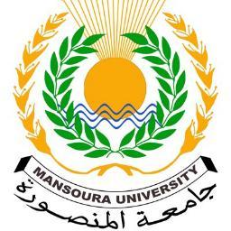

Mansoura University

Faculty of Arts قسم الآثار المصرية- مادة اللغة الانجليزية

Subject: English Final 2019/2020

**--------------------------------------------------------------------------------------**

**د.بسمة عوض- د. يسرا مصطفي**

**Please answer one of the following researches:**

**1. Answer pages 229- 231- 233 from your university book**

**2. Summarize pages 3- 4 from your university book**

**3. Summarize pages 15- 16 from your university book**

**4. Summarize pages 31- 32 from your university book**