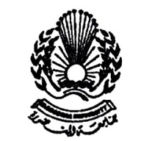
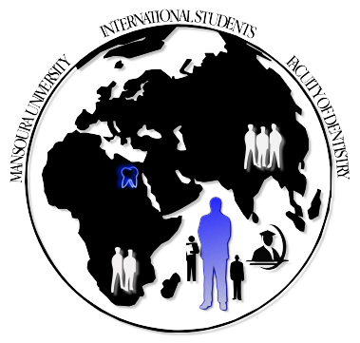

Mansoura University International Dental Student
Faculty of Dentistry Office

Welcome ……….
Dear International Dental Students,
I welcome you to Egypt, the mother and heart of the world that embraced human civilization from ancient times and developed an eternal human message over the ages declaring that human beings are brothers and partners, that knowledge and learning are the bases of progress and prosperity, and that ethics are the foundation of advancement.
It may not come as a surprise to you if I mentioned that for centuries Egyptians rulers invited new neighboring peoples to come and join their institutes of learning and their religious temples, forging a web of love and legality and a texture of knowledge and learning that lasted for countless years.
The various departments of Mansoura Faculty of Dentistry welcome you, and the International Dental Student Office is developing itself to help facilitating your studies, cultural life and social activities. It will do everything that will smooth your stay and increase your love for Egypt and your ties to it.

We also hope to enjoy your stay here in Egypt, explore our culture, people, and history while you are achieving your academic goals.
Prof. Dr. Mohamed Hassan Alkinawi
Dean of the Faculty
Word from officials International Dental Student Office:
The late poet and son of Upper Egypt, Amal Donkel, said that Egypt does not start from ancient Egypt but from the stones of Thebes. He thus encapsulated, in so few words, many books and studies that were and will be written about our good country.

As he mentioned, Egypt is not only the present-day country. It is that civilization and knowledge treasure that no other nation possesses. Its unique place and regional and international status makes of Egypt the center of the world, thanks to its geographical location, ancient culture, contemporary quest for comprehensive progress and development, and aspiration for a future to be organized and advanced by the will of its sons.

In this connection, cultural relations are a key vehicle through which Egyptian culture is taken to the world and the cultures of the world are brought to our country in a process of boundless and untrammeled cultural cooperation.

In seeking to fulfill this goal, the Mansoura Faculty of Dentistry devotes special attention to the foreign students who come to our country for education and knowledge. It offers them significant services in all fields through the International Dental Student Office.
THE INTERNATIONAL DENTAL STUDENT OFFICE

Our main goal in the International Dental Student Office (IDSO) is to offer academic opportunities for the students all over the world.
The office helps foreign students to accommodate and adapt with new community they deal with, through academic, social and psychological support.
The IDSO of Mansoura Faculty of Dentistry guides the international students to achieve strong academic base and develop a great understanding of the Egyptian culture as well.
Mission
The mission of the International Dental Student Office is to provide an integrated professional service to students that:
- Supports and empowers them to achieve their study, personal and career goals;
- Advocates recognition and respect for their diverse cultural backgrounds and individual needs at all levels of the University; and
- Promotes the development of University policies and practices that respond effectively to the changing needs of students.
- Facilitates the administrative procedures for university enrollment.
Objectives
- Support the international dental student in all their needs, academic, social, health and psychological.
- Attract more international dental students to join our academic program.
- Improvement of international relations in the field of education and researches.

The International Dental Student Office extends their sincere thanks to Dr. Heba Mahmmoud Elsabaa for her remarkable efforts in making, designing and completing the wonderful incoming students guide.

Contents
Step 1: EGYPT:
- Where is Egypt?
- Climate.
- Egyptian currency.
Step 2: MANSOURA.
- Location:
- History:
- Culture:
- Get in:
- Get around:
- See:
- Buy
- Eat:
- Accomodation:
- Initial expenses:
- communications:
Step 3: MANSOURA UNIVERSITY:
- Dining in campus:
- Computing in campus:
Step 4: MANSOURA DENTAL SCHOOL:
- International Student Dental Office:
- The infrastructure:
- The academic program:
- Learning resources:
- services:
Contact information
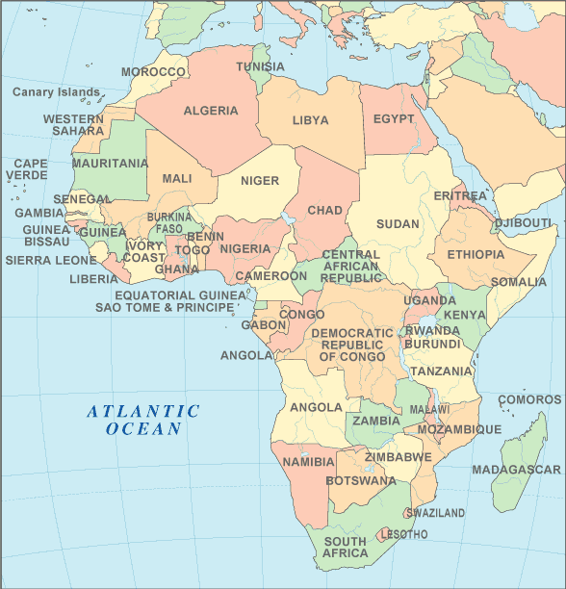
Step 1: Egypt:
Where is Egypt?
Egypt is a country mainly in North Africa, with the Sinai Peninsula forming a land bridge in Southwest Asia. Egypt is thus a transcontinental country, and a major power in Africa, Middle East, the Mediterranean region and the Islamic world. Covering an area of about 1,010,000 square kilometers (390,000 sq mi), Egypt is bordered by the Mediterranean Sea to the north, the Gaza Strip to the northeast, the Red Sea to the east, Sudan to the south and Libya to the west.
Egypt is one of the most populous countries in Africa and the Middle East. The great majority of its estimated 79 million people live near the banks of the Nile River, in an area of about 40,000 square kilometers (15,000 sq mi), where the only arable land is found. The large areas of the Sahara Desert are sparsely inhabited. About half of Egypt's residents live in urban areas, with most spread across the densely populated centers of greater Cairo, Alexandria and other major cities in the Nile Delta.
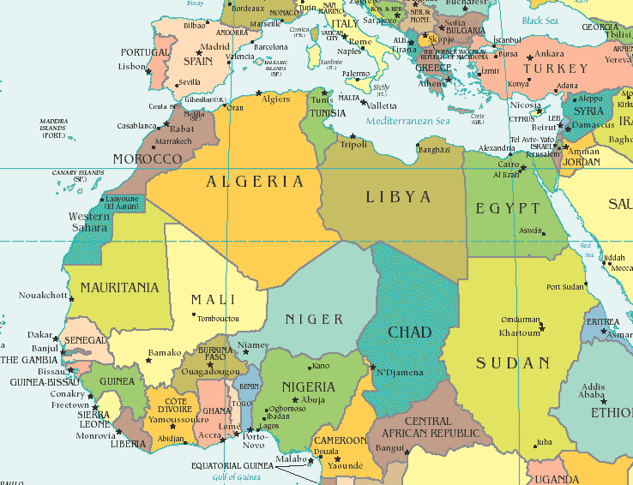
Egypt is famous for its ancient civilization and some of the world's most famous monuments, including the Giza pyramid complex and its Great Sphinx. Its ancient ruins, such as those of Memphis, Thebes, Karnak and the Valley of the Kings, are a significant focus of archaeological study, and artifacts from these sites are now displayed in major museums around the world.
Egypt possesses one of the most developed and diversified economies in the Middle East, with sectors such as tourism, agriculture, industry and service at almost equal production levels. The Egyptian economy is rapidly developing, due in part to legislation aimed at luring investments, coupled with both internal and political stability, along with recent trade and market liberalization
Climate:
Climate in Egypt is commonly moderate. It is mostly hot or warm at days, and cool at nights.
At days in the coastal regions, temperature ranges between an average of minimum 14 °C (57.2 °F) in winter and average of maximum 30 °C (86 °F) in summer.
In deserts, the temperature vary in a great extent especially in summer; they may range from 7 °C (44.6 °F) at night, to 52 °C (125.6 °F) during the day. While during winter temperatures in deserts are widely fluctuate. They can be as low as 0 °C (32 °F) at night, and as high as 18 °C (64.4 °F) during the day.
For details: http://www.world66.com/africa/egypt/mansoura/lib/climate
Egyptian currency:
Our Egyptian pound is written as LE 1.00 and is subdivided into 100 piaster.

Step 2:
Mansoura:
Mansoura means 'The Victorious (city)'. The city is named after the Egyptian victory over Louis IX of France during the Seventh Crusade.

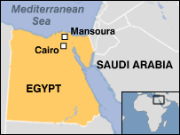
Location:
Mansoura lies on the east bank of the Damietta branch of the Nile, in the Delta region. Mansoura is about 120 km northeast of Cairo. Across from the city, on the opposite bank of the Nile, is the town of Talkha. Mansoura and Talkha together form a metropolitan city.

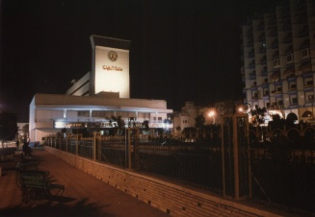
History:
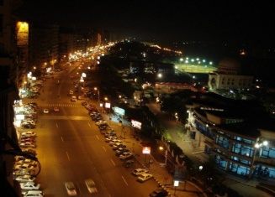
Mansoura was established in 1219 by Saladin's nephew, Abu-Bakr Malik ibn al-Adil I (their phater also known as Saphadin) of the Ayyubid dynasty. After the Egyptians defeated the Crusaders during the Seventh Crusade, it was named Mansoura (aka. "The Victorious").

Culture:
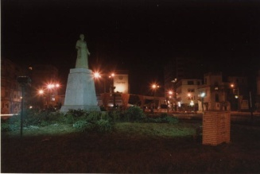
The Egyptian Arabic dialect spoken by Mansoura's population is a northern Egyptian Arabic dialect, with noticeable influences from the city's surrounding rural villages, each of which has contributed to the city's population over the years. There are some similarities to Alexandrian Egyptian Arabic in some aspects of pronunciation.
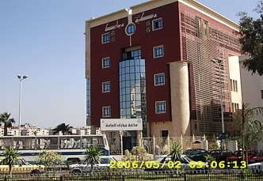
Mansoura National Museum used to be Dar Ibn Lockman, the house where Louis IX was imprisoned in 1250 during the Seventh Crusade. Displayed in the museum are the suits of mail and swords of the crusaders, as well as a collection of maps. Huge paintings depict the Battle of Mansoura.
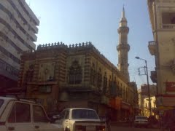
The Mansoura branch of the National Library was recently inaugurated as the Mansoura Mubarak Library.
Mansoura is famous for its architectural style, especially the Shinnawi Palace (after Mohamed Bek El-Shinnawi, a member of the Wafd Party). It was built by an Italian architect in 1928. The mosque of El-Saleh Ayoub El-Kebir is one of the most important in Mansoura. It was built by a loyal servant of the Sultan and is located in Al-Sagha Street that separates "Old Mansoura" from the modern city.
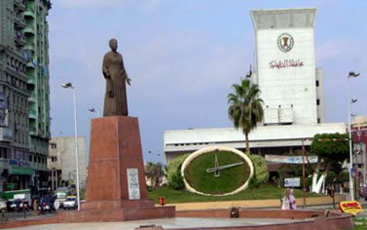
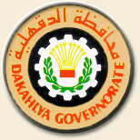
Like Cairo and Alexandria, Mansoura was home to a flourishing Greek community until the Nasserite era, when many were forced to leave. Many of the older and best established shops and businesses around the city still bear their original Greek names. The first English school in the city was established on the site of the old Greek school in the Toriel area, one of the traditionally relatively affluent residential districts of the city.

Get in:
The easiest way to get there is either to take a "Superjet" bus from Cairo's El Ollaly station (10-15 LE) or from Alexandria's SeedyGaber Station (15-20 LE). The journey time is 2 hours from Cairo, 3.5 hours from Alexandria. Authentic scenes of rural Egypt can be seen on the way. Train connections from Cairo and Alexandria are also available on regular basis.

Get around:
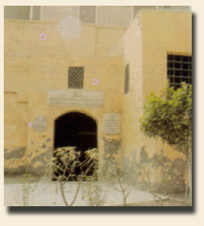
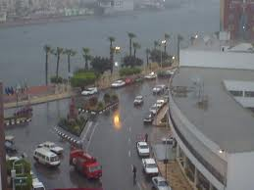
The most convenient (if not, hair-raising) way to get around is by taxi. Local taxis in Mansoura should be paid max 3-4 LE for most journeys for one or two passengers but may be up to 4 or 5 LE if are 2+ passengers with long trips. Shorter journeys could command a cheaper fare of 1.50LE. Taxi Meters are not used. Flag one of the numerous maroon and white cars down at the roadside and shout, "tax" or "taxi", one withdraw is almost all taxi drivers can't speak english or other languages so you'd better know the name of your destination in arabic or to write it in a note. Enjoy the ride.

See:
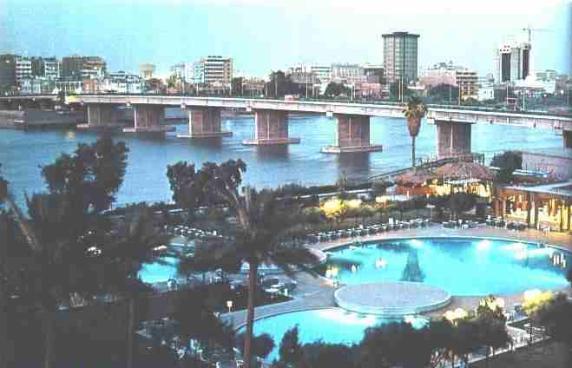
Visit "Dar Ebn lokman", the house of Louis IX of France during his capture in Mansoura. Walk by the mansoura Nile on 'kornish almansoura' or 'almasheya. Take a short boat ride through the Nile to the neighbouring city of Talkha. Visit "Gezirat El-Ward" public garden. You can also take a look at any of the private social clubs in Mansoura "Geziret El-Ward", "El-Hawar" or "Mansoura Stadium".

Buy:
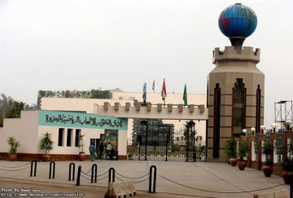
Get your grocery and household merchandise from any of the local supermarkets: "El-Wekala" -3 branches in "El-Mashaya", "El-Mokhtalat" and "El-Ter'a" districts-,"Metro market" at "El-Gam'a district" besides Ramada, "Hypermart" at "Toriel district" or "Awad Allah markets" at Qanat El-Swiss street. All are small to medium-sized supermarkets accepting credit cards and offering home delivery. "El-Wekala" is the most popular and probably the least expensive, but if you are looking for a greater variety of imported goods, head to "Metro".
- For shopping, you can walk through the long street of "El-Sikka El-Gedida" downtown. Where you will find number of well known shops in Mansoura like ELKenawy , Shehata hanafy And El Maleka. It is mostly famous for gold jewelery and clothing. You can also find different types of shops and small groceries as you walk. If you are looking for fancier clothes, however, go to the "Gam'aa" or the Mansoura university district. There, you'll find a number of reasonable shops along the Nile bay "El-mashaya" or in "El-bahr street" in front of the university. Yoy can also take a look at "PortSaid" street, if you are looking for electric or household appliances.

Eat:
A variety of Western, and some local, fast food outlets serve food to the rich in the Gam'a (University) district of town.

Accomodation:
For accommodation, there are a few hotels in town. Just ask about:
- Marshal Hotel: 2 branches: "Marshal el gezira" (located in Elmashaya st.) and "Marshal el mahatta" (opposite to the train station)
- Global Hotel: (formerly Ramada Hotel): located in Elgomhoria st., opposite to Metro Market, it's more luxurious with a pool and better restaurant

Initial expenses:
Visa, Master Card and American express from your home country can be used. We recommend to open an account at a local bank as soon as you arrive, as it is not advisable to carry large amounts of cash.

Communications:
- Phones: You can calling Mansoura from anywhere all over the world by dialing first the overseas code of Egypt (020) then the city code for Mansoura (50) then the number you want. To reach the speaking directory call 140 from any Egyptian phone.
- Cell phones: there are three cellular phone companies in Egypt offering the services. You have a great variety of deals so check it out before you make a decision.
- Numbers you have to keep in mind:
- Rescue emergency | 112
- Ambulance | 123
- Fire emergency | 180
- Electricity emergence | 121
- Water emergency | 125
- Telephone complains | 111
- Cairo International Airport | (02)22655002  (02)22676118

Step 3: Mansoura University:
Mansoura University was found in 1972 in Mansoura city, Egypt. Now, it also has a branch in Damietta. It is one of the biggest Egyptian universities and has contributed much to the cultural and scientific life in Mansoura and Egypt.
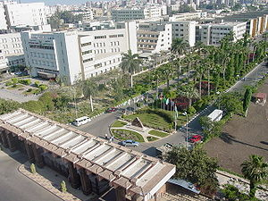
The main Campus is located in Mansoura city. It comprises the following faculties:
- Faculty of Medicine
- Faculty of Education
- Faculty of Science
- Faculty of Pharmacy
- Faculty of Dentistry
- Faculty of Commerce
- Faculty of Law
- Faculty of Engineering
- Faculty of Agriculture
- Faculty of Nursing
- Faculty of Veterinary Medicine
- Faculty of Physical Education
- Faculty of Computer Science & Information Systems
Dining in campus:
The University central restaurant has four floors, the first floor including a kitchen with a capacity of 300 meals/h and a small restaurant for about 700 students. The second and third floors are large restaurants with a capacity of 1200 students each. The fourth floor is the students’ hostel administration and a social club for the students.
Computing in campus:
After registration as a student in the information technology centre of student's services, you will be able to have your own account and e-mail. This will give you the benefits of:
- Receiving your results on your e-mail.
- Downloading up to 200 mega monthly
- Navigating the internet at the hot spot of the campus (garden areas between faculties of engineering and law)
The information and technology centre lies on the right of the Galaa gate of the University. : 0502223693

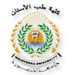
Step 4: Mansoura Dental School:

International Student Dental Office:
Established in 2010, it is a new office at the Faculty of Dentistry, Mansoura University. The main role of this office is to support the international students in their academic life and their social life as well.
For contact, Prof. Dr. Youssry Mahmoud El-Hawary.
e-mail: yhawary2006@yahoo.com
The academic program:
Mansoura Dental school program includes three stages:
- Predental Stage (Predental year):
Which is the preparatory stage, so it is totally basic sciences and is produced in the Faculty of Science, Mansoura University.
- Preclinical Stage (first and second years):
In this stage students use the virtual clinics to train well before the clinical stage.
- Clinical stage (fourth and fifth years):
The students train in the faculty clinics under the supervision of the staff members and their assistants.
The infrastructure:
The faculty has two buildings:
- The old building: (for the clinical stage)
This building is located in the University campus with its main gate on the Elgomhoria Street beside the urology centre.
- The new building: (for the preclinical stage)
This building is located in the campus in front of the central library of the University and Faculty of pharmacy.
Lecture halls:
Three lecture halls in the old building and four in the new building
Laboratories:
Eight student labs in the new building
Simulator laboratories:
Three simulator labs in the new building

- Predental year:
Subject | Lectures (hours) | Practical (hours) | written exam (marks) | practical exam  (marks) | oral exam  (marks) | Total marks
Chemistry | 3 | 3 | 50 | 20 | 15 | 100
Physics & Statistics | 4 | 4 | 70 | 30 | 25 | 150
Botany & Genetics | 2 | 2 | 30 | 20 | 15 | 80
Zoology | 3 | 3 | 50 | 20 | 15 | 100
English language & Medical terminology | 2 | - | 70 | - | - | 80
Total | 15 | 14 | 295 | 105 | 70 | 510
Total | 29

- First year:
Subject | Lectures (hours) | Practical (hours) | written exam (marks) | practical exam  (marks) | Oral exam (marks) |  | Class work (marks) | Total marks
Dental Biomaterials | 2 | 2 | 60 | - | 20 | 20 |  | 100
Descriptive Dental Anatomy | 2 | 2 | 50 | 20 | 15 | 15 |  | 100
Oral Histology | 2 | 2 | 50 | 20 | 15 | 15 |  | 100
General Anatomy | 2 | 4 | 60 | 20 | 20 | 20 |  | 120
General Histology | 1 | 2 | 40 | 15 | 15 | 10 |  | 80
Biochemistry | 2 | 1 | 50 | 20 | 20 | 10 |  | 100
General Physiology | 4 | 2 | 90 | - | 35 | 25 |  | 150
Total | 15 | 15 | 400 | 95 | 140 | 115 |  | 750
Total | 30

- Second year:
Subject | Lectures (hours) | Practical (hours) | Written exam (marks) | Practical exam  (marks) | Oral exam  (marks) | Class work (marks) | Total marks
Prosthodontics Technology | 2 | 4 | 60 | 30 | 15 | 15 | 120
Conservative Dentistry Technology | 2 | 4 | 60 | 30 | 15 | 15 | 120
Crown & Bridge Technology | 2 | 4 | 60 | 30 | 15 | 15 | 120
General Pathology | 2 | 2 | 50 | 20 | 15 | 15 | 100
Pharmacology | 2 | 2 | 50 | 20 | 15 | 15 | 100
Microbiology & Immunity | 1 | 2 | 40 | 15 | 15 | 10 | 80
Total | 11 | 18 | 320 | 145 | 90 | 85 | 640
Total | 29
Human Rights |  | - | 100 |  |  |  | 100
- Third year
Subject | Lectures (hours) | Practical (hours) | Written exam (marks) | Practical exam  (marks) | Oral exam  (marks) | Class work (marks) | Total marks
Removable prosthodontics | 1 | 2 | - | - | - | 50 | -
Conservative Dentistry | 1 | 2 | 40 | 30 | 15 | 15 | 100
Crown & Bridge Technology | 1 | 2 | 40 | 30 | 15 | 15 | 100
Endodontics | 1 | 2 | 40 | 30 | 15 | 15 | 100
Diagnosis & Radiology | 1  1 | 2  2 | 35  30 | 20  15 | 15  10 | 15  10 | 150
Oral surgery and local anesthesia | 2 | 2 | - | - | - | 50 | -
Pediatric Dentistry | 1 | 2 | 40 | 30 | 15 | 15 | 100
Dental public and oral health | 1 | 1 | - | - | - | 20 | -
Orthodontics | 1 | 2 | - | - | - | 35 | -
Oral Pathology | 2 | 2 | 60 | 25 | 20 | 15 | 120
General medicine, Skin & Venereal Diseases | 2 | 2 | 50  20 | 15  - | 15  10 | 10  - | 120
General surgery, ENT & Ophthalmology | 3 | 2 | 50  20  15 | 20  -  - | 15  10  10 | 10  -  - | 150
Total | 18 | 25 | 440 | 215 | 165 | 275 | 940
Total | 43
- Fourth year:
Subject | Lectures (hours) | Practical (hours) | Written exam (marks) | Practical exam  (marks) | Oral exam  (marks) | Class work (marks) | Total marks
Removable prosthodontics | 1 | 4 | 80 | 70 | 25 | 25 | 250
Conservative Dentistry | 1 | 4 | 60 | 40 | 25 | 25 | 150
Prosthodontics | 1 | 4 | 60 | 40 | 35 | 25 | 150
Endodontics | 1 | 2 | 40 | 30 | 15 | 15 | 100
Oral medicine &  Periodontology | 2  1 | -  2 | 50  30 | -  20 | 15  10 | 15  10 | 150
Oral & maxillofacial surgery &  general anesthesia | 3 | 2 | 90  10 | 70 | 25  10 | 25 | 280
Pediatric Dentistry | 1 | 3 | 40 | 30 | 15 | 15 | 100
Dental public and oral health | 1 | 1 | 50 | 25 | 15 | 10 | 120
Orthodontics | 1 | 2 | 70 | 60 | 20 | 15 | 200
Total | 13 | 24 | 580 | 385 | 200 | 180 | 1500
Total | 73

Learning resources:
- The textbooks library:
The library is found in the second floor of the old building. It is open all days except Fridays from 9 am – 4 pm. It has a list of recommended books will help you.
- The digital library:
The e-learning unit of the faculty has a hall with N computers which is available for the students free of charge and is found also in the second floor of the old building.
services:
The faculty mosque
The faculty cafeteria
The Olympic village:
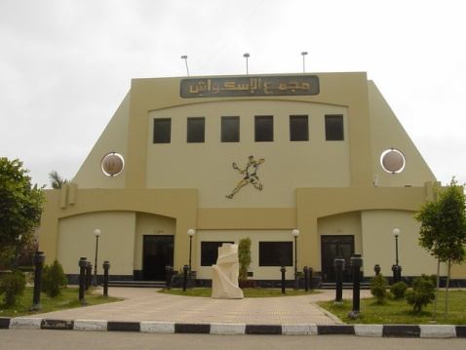
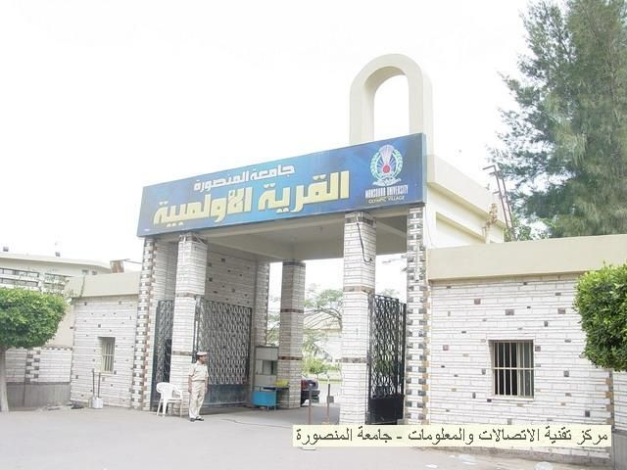
It is an area of 15 acres, it serves students, staff members and even interested members from outside the university. It has sportive stadium, squash courts, tennis, physical fitness unit and a swimming pool.

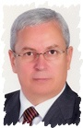
Contact information:

University administration team:

Prof. Dr. Elsayed Ahmed Abdel Khalek

Head of the University

president@mans.edu.eg

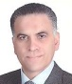

Prof. Dr. Hassan Aly Etman

Vice-head for Education and Students’ Affairs
muvpsa@mans.edu.eg

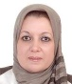

Prof.Dr. Magda Nasr Ahmed Nasr

Vice-head for high studies and researches Affairs

magdahnasr@mans.edu.eg

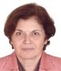

Prof. Dr. Raymonde Hanna Assaf

Vice-head for Environmental affairs and developing community

monda_assaf@mans.edu.eg

Faculty of Dentistry administration team:

Prof. Dr. Mohamed Hassan Alkinawi

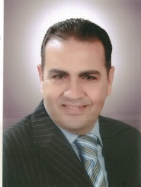
Dean of the faculty

m.kenawy@mans.edu.eg

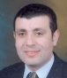

Prof. Dr. Essam El Said El Wakeel

Vice-dean for Education and Students’ Affairs

elwakeel@mans.edu.eg

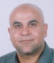

Prof. Dr. Ahmed Ragheb Ahmed Zaher

Vice-dean for high studies and researchs Affairs

ahmedrz2005@mans.edu.eg

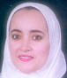

Prof. Dr. Gilan Mohamed Mahmoud Youssif

Vice-dean for Environmental affairs and developing community

jilan_youssef@mans.edu.eg

THE INTERNATIONAL DENTAL STUDENT Unit
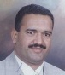
Prof. Dr. Youssry Mahmoud Elhawary
Prof and, head of the oral biology department

Coordinator of International Students
Yhawaery2006@yahoo.com

Ass. Prof. Dr. Lobna Radwan Salem

Ass. Prof. Dr of oral biology

DR. Nesreen Elmekawy
Assistant Prof. of removable Prosthodontic

Mona Denewar
Senior Lecture of oral biology

