CORRICULUM VITAE

PERSONAL DATA 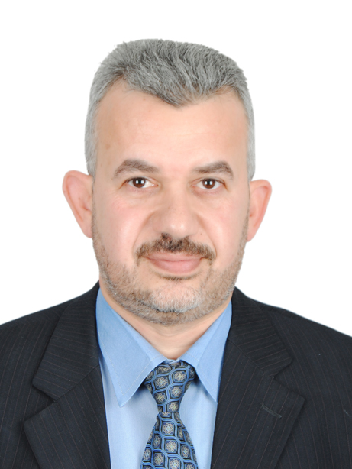

- Name: Ahmed Ahmed Wafa Soliman
- Religion: Muslim
- Marital status: Married with 4 kids
- Birth date: 22-8-1968
- Nationality: Egyptian
- E-mail: abomaryam2002@yahoo.com
aawafa@mansu.edu.eg
- Mobile 01223937098
- Work address: Specialized Medical Hospital, Mansoura University, Mansoura city, Egypt.
- Current position: Professor of Cardiology ,Faculty of Medicine, Mansoura University, Egypt.

EDUCATIONAL DATA
Doctoral Degree:
MD Degree of Cardiovascular medicine from Mansoura
Faculty of medicine in Feb. 2002.
MASTER Degree:
Master (M.Sc) Degree of Cardiovascular medicine from Mansoura
Faculty of medicine in Feb. 1997.
MBBCh Degree:
M.B.B.Ch (Bachelor of medicine and surgery ) Mansoura
Faculty of medicine in Nov. 1992.

PROFESSIONAL HISTORY:
- Professor of Cardiology ,Cardiology department, Mansoura Faculty of medicine till now
- Assistant Professor of Cardiology ,Cardiology department, Mansoura Faculty of medicine, from 22-7-2007 until 30-12-2013
- Lecturer of Cardiology ,Cardiology department, Mansoura Faculty of medicine, from 18-3- 2002 to 21-7-2007.
- Assistant Lecturer of Cardiology ,Cardiology department, Mansoura Faculty of medicine, from 15-11-1997 to 17-3-2002.
- Demonstrator of Cardiology ,Cardiology department, Mansoura Faculty of medicine, from12-10-1997 to 14-11-1997.
- Resident of Cardiology ,Cardiology unit, Mansoura University Hospital and Emergency Hospital, from 17-5-1994 to 11-10-1997
- Primary Health Care physician in Egyptian Ministry of Health Hospitals from 23-3-1994 to 16-5-1994.
- House officer in Mansoura University Hospitals from 1-3-1993 to 28-2-1994.
Medical skills:

- Performing non-invasive cardiovascular assessment techniques as Exercise ECG, Transthoracic Echocardiography (M-mode, 2D, Tissue Doppler, Speckled tracking and Dobutamine Stress Echo) and Trans-esophageal Echocardiography.
- Mastering diagnostic and therapeutic coronary intervention via both femoral and radial approaches including complex techniques (Left main lesions, Bifurcational lesions, CTO).
- Mastering implantation of Pacemakers, and ICDs.
confrencs, workshops and training programes:

- A participant and speaker in several local and international conferences including the EUROPCR PARIS , European Society of Cardiology (ESC) Congress, European Society of Hypertension Working Group (ESH) Barcelona , Cardio Alex conference and Cardio Egypt since , Cardio Risk.
- A participant and speaker in many workshops for trans-radial approach, complex interventional techniques and other workshops for advanced techniques of Echocardiographgy (SelfAssessment Programs EchoSAP 7 certified by The American College of Cardiology Foundation (ACCF).
- Attending and fulfilling the faculty and leadership development progress programs (FLDP) for university staff. These include training program for basics of scientific publications, competitive local and international research projects, Time management training program, Communication skills in various modes of education, Medical ethics training program, credit hour system training program, Research Ethics training program, Strategic planning training program, Organizing scientific conferences training program, Quality standards in teaching process, Financial and legal issues of the university aspects, Using technological advances in the teaching process, Crises and disaster management training program.
- Presedent of working group of hypertension of the Egyptian society of cardiology
- Head of cardiology department in Alfoaad hospital
- Secretary of cardiology department council Mansoura university.
communication and language skills:
‘
- A professional experience in the medical teaching field using different approaches. These include the conventional teaching methods, as well as generating a Problem-based learning (PBL) session which allows the students to learn about a subject through the experience of solving an open-ended problem found in trigger material. The PBL way of teaching has been applied for several years now in Mansoura University via the Manchester teaching program and I have been a part of it for consecutive years.

- Fluently using the English language particularly in the medical field.
- Presentation skills using advanced computer technologies.
- Having patience and receptiveness with anxious patients and ability to perform good decision making which is considered the hard core of my field.
- Understanding, welcoming, and having an open mind to all cultures, religions and nationalities believing that a peaceful society starts with an individual’s inner peace.
Legal considerations:
- A fine reputation throughout the medical career.
- Never been subjected to the ethical committee for any legal or ethical violations.

