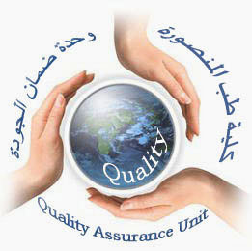  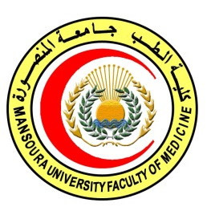 | 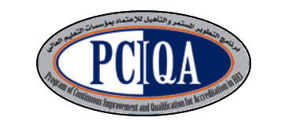 | 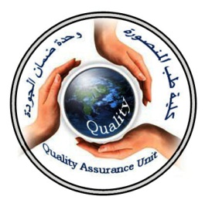

COURSE SPECIFICATION
(Medicine & Surgery related to oncology)
Faculty of Medicine- Mansoura University
- Administrative information

- Programme offering the course: | Postgraduate Master degree of Clinical Oncology and Nuclear Medicine/ CONM517
- Department offering the programme: | Clinical oncology and nuclear medicine department
- Department responsible for teaching the course: | Surgical oncology department
Part of the programme: | second part
- Date of approval by the Department`s council | 14/5/2016
- Date of last approval of programme specification by Faculty council
- Course title: | Medicine& surgery related to oncology
- Course code: | CONM 517 MSO
- Credit hours | 2 hours lectures  1 hour clinical
- Total teaching hours: | 30hours lectures  30 hours clinical
- Professional information

- Course Aims:
The broad aims of the course are as follows:(either to be written in items or as a paragraph)
- Prepare the candidate to know surgical treatment of cancer as main line of treatment
- Educate them the surgical problem related to tumors and their treatment.
- Prepare the candidate to know how to diagnose and treat medical problems result from cancer and treatment of cancer.
- Educate them the medical aspect of cancer different body organs .

- Intended Learning Outcomes (ILOs):
Intended learning outcomes (ILOs); Are four main categories: knowledge & understanding to be gained, intellectual qualities, professional/practical and transferable skills.

On successful completion of the course, the candidate will be able to:
A- Knowledge and Understanding
The trainee should

A1: Explain basics of surgery related to oncology(indication, contraindication, side effects).

A2: Describe surgical aspects of tumors of different parts of body .
A3:identify deep vein thrombosis, and shock related to cancer
A3: Explain medical problems related to cancer and its management.
A4: Recognize prevention methods.
A5: discuss medical aspect of cancer of different organs.

2- Intellectual activities (I)
The Postgraduate Degree provides opportunities for candidates to achieve and demonstrate the following intellectual qualities:
B- Intellectual skills

B1: Differentiate between masses in any parts.
B2:Distinguish benign of malignant tumors.
B3:illusterate DVT and shock and its 1st aid measures
B4: interpret medical disorders related to oncology.
B5: recognize prevention and medical aspects of tumors of different body organs.

C- Professional/practical skills
Training should give appropriate experience in the areas identified below:
C1: Apply differential diagnosis of masses of different body parts.
C2: Descripe full characters of masses.
C3: differentiate differents types of shock and apply 1st aid measures
C4:diagnose and apply 1st aid of DVT
C5:differentiate different types of jaundice.
C6:develop skills in using hormones in cancer.
C7:Differentiate between and manage medical problems interfere with cancer.
C8:be able to detect and prevent cancer early

D- Communication & Transferable skills

D1: Trainees must be able to.
Explain the procedure of diagnosis and treatment details honestly in language appropriate to patients and their families.

D2: Trainees must instruct family and patients with side effect and how to deal.

- Course content (Basic of surgery): total: 30 hours
Subjects | Lectures
*Deep vein thrombosis(DVT) | 1
* Shock | 1
*Breast:  -Benign breast diseases  -Cancer breast | 1  2
*Thyroid  -Thyrotoxicosis  -Cancer thyroid | 1  2
*Head and neck  -Tongue ulcer  -lip ulcer  -Jaw swelling | 1  1  1
*Gastro-intestinal tumors  -Oesophageal  -Liver tumors  -Pancreatic tumors  -Colorectal tumors  -Stomach tumorss | 1  0.5  0.5  1  1

Course content (Medicine):
Subjects | Lectures
-Hormone and cancer | 2
-Prevention and early detection of cancer | 1
-Paraneoplastic  -Gastric tumor | 1  1
-colonic tumor  -hepatocellular carcinoma | 1  1
-hepatic focal lesion  -Jaundice  -lung cancer  -hypercalcaemia  -pituitary dysfunction  -thyroid nodule  -goitre  -lymphoma  -plasma cell disorders | 1  1  1  0.5  1  1  0.5  1  1

Course content (Clinical sessions): total: 30 hours
Basic of surgery
Diagnosis and 1st aid measures of DVT | 1
Differentiate different types of shock | 1
1st aid measures of shock | 1
Differential diagnosis of breast lumb | 2
Clinical staging of breast cancer | 1
Examination of breast and axilla | 1
Differential diagnosis of thyroid nodule | 1
Assessment of thyrotoxic manifestation | 1
Examination of neck | 2
Diagnosis and differentiation of ulcers of H&N | 1
Assessment of head and neck swelling | 1
Performing abdominal examination | 1
Differential diagnosis of abdominal swellings | 1
Medicine
Ability to detect cancer early | 2
Diagnose paraneoblastic syndromes | 1
Differential diagnosis of types of jaundice | 1
Using hormonal treatment in cancer and manage side effects | 2
Management of medical problems related to cancer | 2
Detection and management of metabolic disorders  related to cancer | 2
Detection of hormonal disorders | 1
Diagnose and differentiate haematologic disorders | 2
Management of lymphoma | 2

4)Teaching methods:
4.1: lectures
4.2: case presentation.
4.3: panel discussion

- Assessment methods:
5.1: written exam for assessment ofknowledge and intellectual skills.
5.2: OSCE clinical exam for assessment ofknowledge , intellectual skills,and practical.
5.3:Structured oral exam for assessment ofknowledge , intellectual skills

Assessment schedule:
Assessment 1: written exam held after 36 months of admission to job or 30 months of registration to the MS degree.
Assessment 2: Oral exam held after 36 months of admission to job or 30 months of registration to the MS degree.
Assessment 3: MCQ exam held at the end of 2nd, 3rd, 4th semester.

Percentage of each Assessment to the total mark:
Written exam:110 marks,
MCQ: 30 marks.
Oral exam: 75 marks,
clinical exam: 75 marks,
References of the course:
6.1: Text books:
Harrison : Internal medicine
Belly and Love: Surgery

- Facilities and resources mandatory for course completion:

Candidates and their learning are supported in a number of ways:
□Candidates logbook
□ Programme Specification
□Extensive library and other learning resources
□Computer laboratories with a wide range of software
□Intranet with a wide range of learning support material
□MSc/MD Dissertation Supervisor

Course coordinator:
Prof.d: Soumaya Eiteba
Assisstant prof: Rasha Abdel Latif

Head of the department:
Prof.d: Ibrahim Awad

Date:

P.S. This specification must be done for each course.

