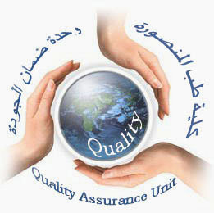  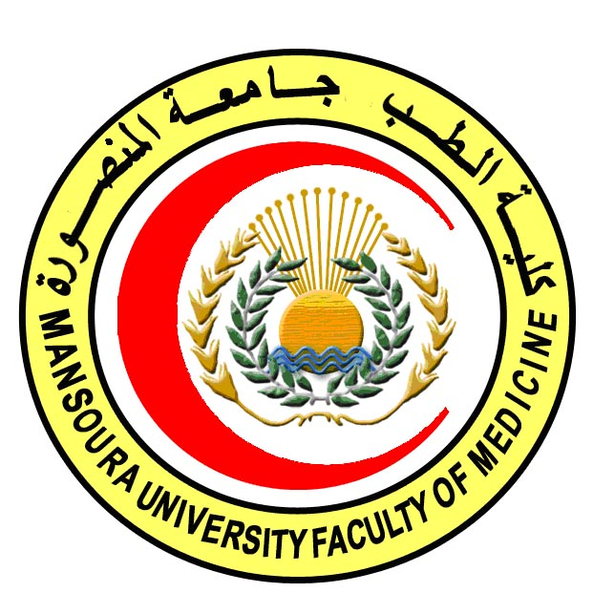 | 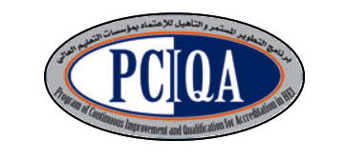 | 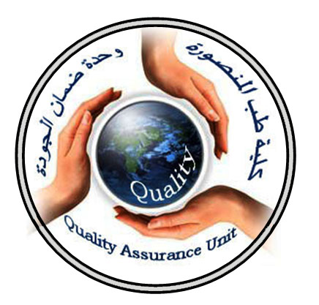

COURSE SPECIFICATION
Nuclear Medicine (level 1)
Faculty of Medicine- Mansoura University
- Administrative information

- Programme offering the course: | Postgraduate Master degree of Clinical Oncology and Nuclear Medicine/ CONM517
- Department offering the programme: | Clinical oncology and nuclear medicine department
- Department responsible for teaching the course: | Clinical oncology and nuclear medicine department
- Part of the programme: | First part
- Date of approval by the Department`s council | 14/5/2016
- Date of last approval of programme specification by Faculty council
- Course title: | Nuclear Medicine( level 1)
- Course code: | CONM517NM1
- Total teaching hours: | 15 hours

- Professional information

- Course Aims:
The broad aims of the course are as follows: (either to be written in items or as a paragraph)

- Educate the terminology of nuclear medicine.

- Prepare the candidate to be able to use isotopes, machines, hot lab.

- Provid the candidate with the different pharmaceuticals, how to prepare, and complications.

- Intended Learning Outcomes (ILOs):
Intended learning outcomes (ILOs); Are four main categories: knowledge & understanding to be gained, intellectual qualities, professional/practical and transferable skills.

On successful completion of the course, the candidate will be able to:
A- Knowledge and Understanding
A1: Identify the major basis of nuclear medicine.

A2: Define laboratory techniques used, dose preparation and complications.

A3: Describe health physics, waste disposal and decontamination.

A4:Explain concepts of quality control in nuclear medicine.
A5: Identify patient selection, and complication and how to manage.
A6:list radiopharmacology and radioimmunoassay.

2- Intellectual activities (I)
The Postgraduate Degree provides opportunities for candidates to achieve and demonstrate the following intellectual qualities:

B- Intellectual skills

B1: interprete preparation, indication, waste disposal of different pharmaceuticals.
B2: recognize patient selection, different instrumentation and precautions.
B3:demonsterate radionuclide production, use, and exposure to unsealed sources.
B4: illusterate quality control.

D1: Trainees must be able to.
Explain the procedure of diagnosis and treatment details honestly in language appropriate to patients and their families.

D2: instruct the patients and family with the possible side effect and how to deal

D- Communication &Transferable skills

- Course content:
Subjects | Lectures
*General basis of nuclear medicine. | 2
*Laboratory techniques used in nuclear medicine including preparation of standards. | 1
*Dose preparation and quality assurance  of the dose calibrators. | 2
*Radiopharmacology. | 1
*Health physics-waste disposal and decontamination. | 2
* Radioimmunoassay and radioimmunotherapy | 1
* Concepts of quality control in nuclear medicine. | 1
* Radiation exposure of unsealed sources. | 2
* Instrumentation.
- Patient selection and preparation | 1
- Complications and precaution | 1
Radionuclides production and use | 1
- Teaching methods:

4.1: Lectures
4.2: Scientific meetings
4.3: Case presentation
4.4: PANEL disscussion

- Assessment methods:

5.1: written exam for assessment of knowledge , intellectual ILOs, and Professional/practical skills .
5.2: oral exam for assessment of knowledge , intellectual ILOs, and practical skills.
5.3 MCq continuous assessment for assessment of knowledge , intellectual ILOs

Assessment schedule:
Assessment 1: written exam held after 6 months of registration.
Assessment 2: oral exam held after 6 months of registration and structured oral exam.
Assessment 4: MCQ exam held at the end of first semester (15th week).

Percentage of each Assessment to the total mark:
Written exam: 144 marks,
MCQ. 36 marks.
Oral exam: 120 marks.

- References of the course:

6.1: Text books:
- Fred A. Mettler and Milton J. Guiberteau: Essentials of Nuclear Medicine Imaging, 5th edition 2006

- Shackett., Nuclear Medicine Technology: Procedures and Quick Reference, (2ND edition 2008)

6.3: Journals:
seminars in nuclear medicine
6.1: Websites:
www.snm.com

- Facilities and resources mandatory for course completion:

Candidates and their learning are supported in a number of ways:
□ Candidates logbook
□ Programme Specification
□ Extensive library and other learning resources
□ Computer laboratories with a wide range of software
□ Intranet with a wide range of learning support material
□ MSc/MD Dissertation Supervisor
Course coordinator:
Prof.d: Soumaya Eiteba
Assisstant prof: Rasha Abdel Latif

Head of the department:
Prof.d: Ibrahim Awad

Date:

P.S. This specification must be done for each course.

