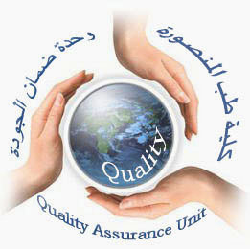  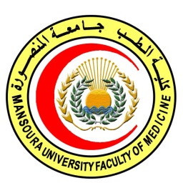 | 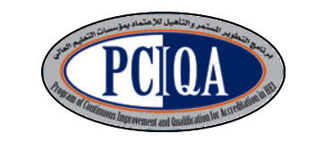 | 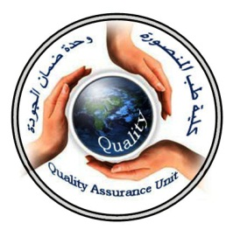

COURSE SPECIFICATION
(Nuclear Medicine level 2)
Faculty of Medicine- Mansoura University
- Administrative information

- Programmeoffering the course: | Postgraduate Master degree of Clinical Oncology and Nuclear Medicine/ CONM517
- Department offering the programme: | Clinical oncology and nuclear medicine department
- Department responsible for teaching the course: | Clinical oncology and nuclear medicine department
- Part of the programme: | Second part
- Date of approval by the Department`s council | 14/5/2016
- Date of last approval of programme specification by Faculty council
- Course title: | Nuclear Medicine
- Course code: | CONM 517 NM2
- Credit hours | 4 hours
- Total teaching hours: | 60 hours lectures

- Professional information

- Course Aims:
The broad aims of the course are as follows:(either to be written in items or as a paragraph)

- Provide the concepts and terminology of Nuclear Medicine .
- Educate the preparation of dose, protection, and quality control.

- Teach the use of different radio-isotopes in the diagnosis and treatment of different diseases.

- Intended Learning Outcomes (ILOs):
Intended learning outcomes (ILOs); Are four main categories: knowledge & understanding to be gained, intellectual qualities, professional/practical and transferable skills.

On successful completion of the course, the candidate will be able to:
A- Knowledge and Understanding
A1:Explain the general basis of nuclear medicine
A2:Explain concepts of quality control in nuclear medicine.

A3: Identify uses of nuclear in diagnosis and treatment of different body parts.

A4: Discuss radiopharmacology, radioimmunoassay, and instrumentation and how to use.
A5: Demonstrate radiation exposure of unsealed isotopes.
A 6 : describe laboratory techniques used in dose preparation and waste disposal.
A 7 : Identify different devices in nuclear medicine

2- Intellectual activities (I)

The Postgraduate Degree provides opportunities for candidates to achieve and demonstrate the following intellectual qualities:

B- Intellectual skills

B1: Practice diagnostic and therapeutic use of isotopes in different body systems.
B2: Distinguish the dose preparation, waste disposal.
B3: interprete different techniques according to the diagnosis.
B4: Analyse concepts of quality control, and different devices.
B5:demonsterate radiopharmacology

- Course content:
semistar | Subjects | Lectures | Clinical | Laboratory | Field | Total Teaching  Hours
1st | *General basis of nuclear medicine. | 3 |  |  |  | 3
1st | *Laboratory techniques used in nuclear medicine including preparation of standards. | 2 |  |  |  | 2
1st | *Dose preparation and quality assurance  of the dose calibrators. | 3 |  |  |  | 3
1st | *Radiopharmacology. | 2 |  |  |  | 2
1st | *Health physics-waste disposal and decontamination. | 2 |  |  |  | 2
1st | Nuclear medicine detectors | 3 |  |  |  | 3
2nd | * Concepts of quality control in nuclear medicine. | 2 |  |  |  | 2
2nd | * Radiation exposure of unsealed sources. | 2 |  |  |  | 2
2nd | * SPECT  *Monitoring devices | 1  1 |  |  |  | 2
2nd | *PET  *whole body counters  *scintillation counters | 1  1  1 |  |  |  | 3
2nd | * Therapeutic uses of isotopes:  -thyroidcancers,  - thyrotoxicosis,  -bone metastasis, | 2  2  2 |  |  |  | 2  2  2
3rd | * Diagnostic scintigraphic studies of:  -brain,  -myocardium  -kidney  - thyroid  -parathyroid  -lung  -bone  - liver  -spleen  - pancreas  -salivary glands  -gastrointestinal  -genitourinary  -reticuloendothelial systems | 2  2  2  3  2  3  2  2  2  2  2  2  2  2 |  |  |  | 2  2  2  3  2  3  2  2  2  2  2  2  2  2

- Teaching methods:
4.1: Lectures
4.2: Scientific meetings
4.3: Case presentation
4.4: PANEL discussion
4.5. Club journal

- Assessment methods:

5.1: written exam for assessment of Knowlede and intellectual skills.
5.2: oral exam for assessment ofKnowlede and intellectual skills, and practical skills.

Assessment 1: written exam held after 36 months of admission to job or 30 months of registration to the MS degree.
Assessment 2: Oral exam held after 36 months of admission to job or 30 months of registration to the MS degree.
Assessment 3: MCQ exam held at the end of 2nd, 3rd, 4th semester.

Percentage of each Assessmentto the total mark:
Written exam: 120 marks ,
MCQ (as a continuous assessment).30 marks.

Oral exam: 150marks,.

- References of the course:

6.1: Text books:
- Fred A. Mettler and Milton J. Guiberteau: Essentials of Nuclear Medicine Imaging, 5th edition 2006

- Shackett.,Nuclear Medicine Technology: Procedures and Quick Reference, (2ND edition 2008)

6.3: Journals:
Seminars in nuclear medicine
6.1: Websites:
www.snm.com

- Facilities and resources mandatory for course completion:

Candidates and their learning are supported in a number of ways:
□Candidates logbook
□ Programme Specification
□Extensive library and other learning resources
□Computer laboratories with a wide range of software
□Intranet with a wide range of learning support material
□MSc/MD Dissertation Supervisor

Course coordinator:
Prof.d: Soumaya Eiteba
Assisstant prof: Rasha Abdel Latif

Head of the department:
Prof.d: Ibrahim Awad

Date:
P.S. This specification must be done for each course.

