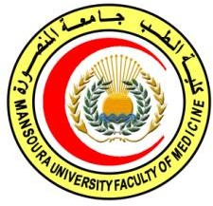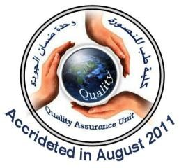





Pathology of Tumors







 | 
 | 

 | 
 | 6/5/2020
 | 20/9/2020
 | Pathology of Tumors
 | CONM 605
 | 
 | 

1











1- Educate the different pathologic types of different malignancies. 2- Teach the genetic basis of different types of cancers
3- Provide the candidates with pathology of cancer of different body parts.



The trainee should: know and understand: A1: Identify carcinogenesis and tumors growth. A2: Discuss hormones and cancer.
A3: Describe tumor markers.
2

A4: Describe pathology of different body parts.









B1: Differentiate between benign and malignant tumors.

B2: Distinguish the biology of tumor growth. B3: Recognize spread of malignant tumors.




 | 
*General pathology:  -Neoplasia  -Tumor growth  -Carcinogenesis  -Tumor markers  -Hormones & cancers | 
*Special pathology:  -pathology of head and neck tumors.  - pathology of brain  malignancies. | 

-pathology of lung and pleural ca  - pathology of gastro-intestinal malignancies  -    - pathology of male genital system tumors | 
- pathology of urothelial system tumors  - pathology of breast cancer  *pathology Soft tissue sarcomas  *pathology of Bone sarcomas  *pathology of Skin cancer and melanomas.  *pathology of Cancer of the endocrine system ( thyroid, parathyroid, adrenals, pancreas, carcinoid).  - pathology of Solid tumors of childhood.  *Leukemias, lymphomas and |     

plasma cell neoplasms.

(4) Teaching methods:
4.1: lectures
4.2, interactive teaching


















- Perez CA, Brady LW,Halperin EC,et al.,editors. Principles and Practice of RadiationOncology.7th edition. Wolters Kluwer, 2018
- Zhong, Jim. "Book Review: Handbook of Evidence-Based Radiation Oncology." (2019).
- Chmielowski, Bartosz, and Mary Territo. Manual of clinical oncology. Lippincott Williams & Wilkins, 2017.
- DeVita, Hellman, and T. S. Lawrence. "Rosenberg’s. Cancer Principles & Practice of Oncology [Internet]." (2019).



Candidates and their learning are supported in a number of ways:
□Candidates logbook
□ Programme Specification
□Extensive library and other learning resources
□Computer laboratories with a wide range of software
□Intranet with a wide range of learning support material
□MSc/MD Dissertation Supervisor
Course Coordinator:
Prof Dr Mohamed El Awady
Prof Dr Ghada Ezzat Eladawei
Head of Department : Prof Dr Magda Allam

6/5/2020

We certify that all information required to deliver this programme is contained in the above specification and will be implemented. All course specification for this
program are in place.
Programme coordinator:  Prof Dr: Mohamed Elawady  Prof Dr: Ghada Ezzat Eladawei | Signature & date:
Dean:  Prof Dr: Nesreen Salah Omar | Signature & date:
Executive director of the quality assurance unit:  Prof Dr: Nesreen Shalaby | Signature & date:

