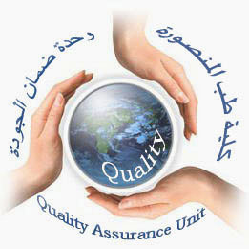  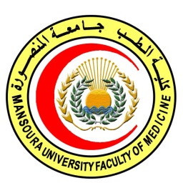 | 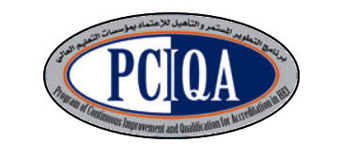 | 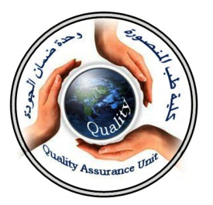

COURSE SPECIFICATION
(Tumor biology,Radiobiology& Radiation protection)
Faculty of Medicine- Mansoura University
- Administrative information

- Programme offering the course: | Postgraduate Master degree of Clinical Oncology and Nuclear Medicine/ CONM517
- Department offering the programme: | Clinical oncology and nuclear medicine department
- Department responsible for teaching the course: | Clinical oncology and nuclear medicine department
- Part of the programme: | First part
- Date of approval by the Department`s council | 14/5/2016
- Date of last approval of programme specification by Faculty council
- Course title: | Tumor biology, Radiobiology& Radiation protection
- Course code: | CONM517RBP
- Credit hours | 1 hour lecture  1 hour clinical
- Total teaching hours: | 15 hours lectures  30 hours clinical

- Professional information

- Course Aims:
The broad aims of the course are as follows: (either to be written in items or as a paragraph)
Each trainee in Clinical Oncology & Nuclear Medicine who
complete this course should be able to:
1- Educate the molecular basis of cancer cells.
2- Provide opportunities to gain knowledge, practice and studying of radiation and chemotherapy effect .
2- teach the candidates different schedules of radiation and their modifiers.
3- Prepare them to be capable of using radioprotectors and radiosensitizers including chemotherapy.
4-educate them chemotherapeutic groups.
5- privde the opportunity to recognize molecular basis, effect , resistance and toxicity of chemotherapy.

- Intended Learning Outcomes (ILOs):
Intended learning outcomes (ILOs); Are four main categories: knowledge & understanding to be gained, intellectual qualities, professional/practical and transferable skills.

On successful completion of the course, the candidate will be able to:

A- Knowledge and Understanding
A1: describe molecular cell biology of tumor, cell cycle, cell survival curve.
A2: Describe Principles of radiation protection, to be capable of safe radiotherapy practice.
A3: Recognize radiation interaction with matter, and its effect on different body organs repair of cell damage after radiation.
A4:Classify chemotherapeutic drugs and groups.
A5:Identify molecular basis of sensitivity and resistance to radiation and chemotherapy.
A6:express growth factors receptors and target therapy
A7:explain oxygen effect and different fractionation shedules.

2- Intellectual activities (I)
The Postgraduate Degree provides opportunities for candidates to achieve and demonstrate the following intellectual qualities:

B- Intellectual skills

B1: Distinguish different factors affecting radiation.
B2: Interprete radiation and chemotherapy effect and interaction with different body organs.
B3:Apply different radiation shedules.
B4: recognize growth factors receptors, and target therapy.
B5:distinguish chemical modifiers, sensitivity and resistance to treatment.
.

C- Professional/practical skills

C1: Evaluate acute and late effect of radiation on different tissues and body organs.
C2: Examine response to chemotherapy during radiation.
C3:Deal with chemotherapy and radiation toxicity.
C4:be able to recognize chemical modifiers, radiosensitizer and radioprotectors
C5:apply different fractionation

- Course content:15 hours lectures
Subjects | Lectures
* Principles of molecular cell Biology of cancer: DNA Structure, gene expression, human genome, identification of  oncogenes and tumor suppressor  genes and implication for oncology | 0.5
* Cell cycle, tumor growth and molecular biology of the cell cycle. | 0.5
* Cell survival curves | 0.5
* Chromosome abnormalities in human  cancers and leukemia. | 0.5
*Growth factors and Growth factor  receptors and relation to malignancy and targeted therapy | 0.5
* Radiobiology: radiation interaction with biological material, cell repair of radiation damage, relative biologic effectiveness. | 0.5
*Linear energy transfer (LET).  *High LET. | 0.5
*Oxygen effect and reoxygenation | 0.5
*Radiation dose and fractionation | 0.5
* Tumor radiobiology , radiosensitivity, adverse effects of radiation. | 0.5
*Radiosensitizers and radioprotectors. | 0.5
*Effect of radiation on different tissues  and organs.  -Skin  -liver  -Lung  -Digestive system  -Testis and ovaries  -Central nervous system  -Cardiac system  -Hemopoietic and lymphoid  -Kidneys  -Skeletal system | 0.5  0.5  0.5  0.5  0.5  0.5  0.5  0.5  0.5  0.5
*Acute and late effects of whole body  irradiation | 0.5
*Chemical modifiers of radiation.  *Chemotherapy and irradiation.  * Biology of cancer chemotherapy,  *Biochemical resistance to chemotherapy.  *Molecular basis of chemosensitivity&chemoresistance.  *Chemotherapeutic drugs and groups.  *Chemotherapy toxicity.  * Response to chemotherapy and biology  of tumor growth | 0.5  0.5  0.5  0.5  0.5  0.5  0.5  0.5
- Course contents : clinical training (30 Hours)
Clinical skill | Teaching hours
*Effect of radiation on different tissues  and organs.  -Skin  -liver  -Lung  -Digestive system  -Testis and ovaries  -Central nervous system  -Cardiac system  -Hemopoietic and lymphoid  -Kidneys  -Skeletal system | 2  1  2  2  1  2  1  2  1  2
*Radiation dose and fractionation | 2
*Radiosensitizers and radioprotectors | 2
*Acute and late effects of whole body  irradiation | 2
*Chemical modifiers of radiation. | 2
*Chemotherapy and irradiation. | 2
*Chemotherapy toxicity. | 2
* Response to chemotherapy and biology  of tumor growth | 2

- Teaching methods:
4.1: lectures.
4.2: scientific meetings

- Assessment methods:

5.1: written exam for assessment of Knowledge and understanding.
5.2: oral exam for assessment of Knowledge and understanding and intellectual skills.
5.3 MCQ assessment for assessment of Knowledge and understanding.

Assessment schedule:

Assessment 1: written exam held after 6 months of registration.
Assessment 2: oral exam held after 6 months of registration and structured oral.
Assessment 3: MCQ exam held at the end of first semester (15th week).
Assessment 4: clinical exam held after 6 months of registration and OSCE stations

Percentage of each Assessment to the total mark:
Written exam: 144 marks,
MCQ (as a continuous assessment). 36 marks
Structured Oral exam: 60 marks,
OSCE Clinical exam: 60 marks

- References of the course:

6.2: Text books:

● PerezCA, Brady LW,HalperinEC,etal.,editors.Principles and Practice of RadiationOncology. 5th ed. Philadelphia:Lippincott
Williams&Wilkinns; 2008.
●Hansen EK and Roach M.: Handbook of Evidence-based Radiation
Oncology.1st edition. New York: springer science+ business media,
LLC; 2007.
●Casciato DA, editor. Manual of clinical oncology.6th edition.
Philadelphia: Lippincott Williams&Wilkins; 2009.
●DeVita VT, Hellman S, Rosenberg SA, editors. Principles and Practice of Oncology.8th ed. Philadelphia: Lippincott; 2008.

- Facilities and resources mandatory for course completion:

Candidates and their learning are supported in a number of ways:
□Candidates logbook
□ Programme Specification
□Extensive library and other learning resources
□Computer laboratories with a wide range of software
□Intranet with a wide range of learning support material
□MSc/MD Dissertation Supervisor

Course coordinator:
Prof.d: Soumaya Eiteba
Assisstant prof: Rasha Abdel Latif

Head of the department:
Prof.d: Ibrahim Awad

Date:

P.S. This specification must be done for each course.

