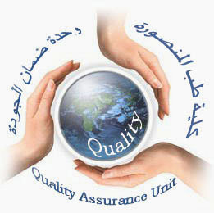  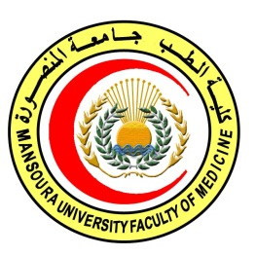 | 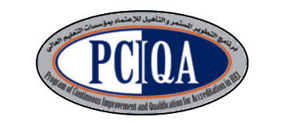 | 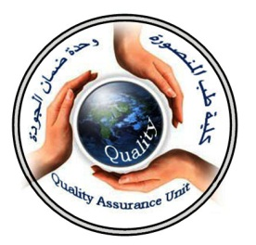

COURSE SPECIFICATION
(Radiation technology)
Faculty of Medicine- Mansoura University
- Administrative information

- Programme offering the course: | Postgraduate Master degree of Clinical Oncology and Nuclear Medicine/ CONM517
- Department offering the programme: | Clinical oncology and nuclear medicine department
- Department responsible for teaching the course: | Clinical oncology and nuclear medicine department
- Part of the programme: | First part
- Date of approval by the Department`s council | 14/5/2016
- Date of last approval of programme specification by Faculty council
- Course title: | Radiation technology
- Course code: | CONM517RTec
- Credit hours | 1 hour lectures  1 hour clinical
- Total teaching hours: | 15hours lectures  30 hours clinical

- Professional information

- Course Aims:
The broad aims of the course are as follows: (either to be written in items or as a paragraph)
1- Educate the concepts and terminology of radiation technology.
2Teach the various radiotherapeutic tools used in day to day oncological practice, and be aware of indications, contraindications, normal tissue tolerances (adult and pediatrics) and the management of radiation reactions and complications.
3- Prepare radiotherapist to analyze the technique-based specialities:
2D treatment techniques, 3D treatment techniques,Conformal radiotherapy.
IMRT techniques, Brachy therapy.
4-Provide the various radiotherapeutic procedures and its side effects
5-Educate the plan of treatment for each patient according to the stage of disease.

- Intended Learning Outcomes (ILOs):
Intended learning outcomes (ILOs); Are four main categories: knowledge & understanding to be gained, intellectual qualities, professional/practical and transferable skills.

On successful completion of the course, the candidate will be able to:
A- Knowledge and Understanding
A1: Recognize general principles of radiotherapy.
A2: Describe different Radiation modalities and individualized techniques to different body organs.
A3:Express principles of radiotherapy equipments and machines.
A4 : Discuss principles of radiotherapy planning with brachytherapy.

2- Intellectual activities (I)
The Postgraduate Degree provides opportunities for candidates to achieve and demonstrate the following intellectual qualities:

B- Intellectual skills

B1: Interpret individualized radiotherapy techniques to tumour of different sites
B2: Distinguish the indications, contraindications and potential complications of radiotherapy in order to plan and prescribe appropriate treatment for common malignancies.
B3: Use different radiotherapy machines and equipments.

C- Professional/practical skills
C1: Designs the plan of treatment to System-based site specialities:
• breast cancer • thoracic malignancy
• upper and lower gastrointestinal (GI) • head and neck
• sarcomas • gynaecological oncology
• urological malignancy and germ cell tumours • neuro-oncology
• skin tumours • lymphomas
• pediatrics oncology
C2: Applies different techniques to different body parts
C3:experiment different machines (linear accelerator, telecobalt, kilovoltage, simulators)

- Course content: lectures 15 hours
Subjects | Lectures
* General principles of radiotherapy of tumors: radiotherapy objectives, side effects and complications. | 2
* Radiation modalities: external beam, brachytherapy, sealed radioactive sources . | 1
* Radiotherapy equipments and machines: linear accelerators, telecobalt, kilovolage X-ray machines and Simulators. | 1
* Principles and basic techniques of radiation oncology | 1
* Individualized radiotherapy techniques to tumour of different sites:  -Brain.  -Head and neck;  -Breast  - Thyroid&lung  - Gastrointestinal  - Genitourinary system  - Skin  - Bone& Soft tissue tumors  - haematological  - Pediatric tumors | 1  2  1  1  0.5  1  1  1  0.5  1

- Course content: clinical 30 hours
radiotherapy side effects and complications. | 1
external beam | 2
linear accelerators | 2
telecobalt,. | 1
kilovolage X-ray machines | 1
Simulators | 1
techniques of radiation oncology  *2D  *3D | 1  1
* Individualized radiotherapy techniques to tumour of different sites:  -Brain.  -Head and neck;  -Breast  - Thyroid&lung  - Gastrointestinal  - Genitourinary system  - Skin  - Bone& Soft tissue tumors  - haematological  - Pediatric tumors | 2  2  2  2  2  2  2  2  2  2

Teaching methods:
4.1: lectures.
4.2: scientific meetings

- Assessment meth ods:

5.1: written exam for assessment of Knowledge and understanding.
5.2: oral exam for assessment of Knowledge and understanding, intellectual skills, practical and professional skills and structured oral exam.
5.2:clinical exam for assessment of, intellectual skills, practical and professional skills and OSCE stations ..

Assessment schedule:

Assessment 1: written exam held after 6 months of registration.
Assessment 2: oral exam held after 6 months of registration and structured oral exam .
Assessment3: clinical exam held after 6 months of registration and OSCE stations.
Assessment 4: MCQ exam held at the end of the semester (15th week).

Percentage of each Assessment to the total mark:
Written exam: 144marks,
MCQ (as continuous assessment). 36 marks.
Oral exam: 60 marks,
clinical exam: 60 marks,

References of the course:

6.2: Text books:

● PerezCA, Brady LW,HalperinEC,etal.,editors.Principles and Practice of RadiationOncology. 5th ed. Philadelphia:Lippincott
Williams&Wilkinns; 2008.
●Hansen EK and Roach M.: Handbook of Evidence-based Radiation
Oncology.1st edition. New York: springer science+ business media,
LLC; 2007.
●Casciato DA, editor. Manual of clinical oncology.6th edition.
Philadelphia: Lippincott Williams&Wilkins; 2009.
●DeVita VT, Hellman S, Rosenberg SA, editors. Principles and Practice of Oncology.8th ed. Philadelphia: Lippincott; 2008.

- Facilities and resources mandatory for course completion:

Candidates and their learning are supported in a number of ways:
□Candidates logbook
□ Programme Specification
□Extensive library and other learning resources
□Computer laboratories with a wide range of software
□Intranet with a wide range of learning support material
□MSc/MD Dissertation Supervisor
Course coordinator:
Prof.d: Soumaya Eiteba
Assisstant prof: Rasha Abdel Latif

Head of the department:
Prof.d: Ibrahim Awad

Date:

P.S. This specification must be done for each course.

