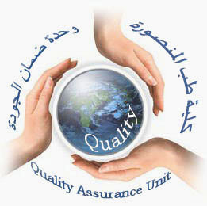  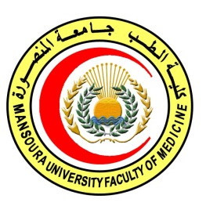 | 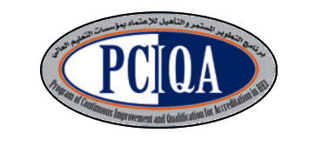 | 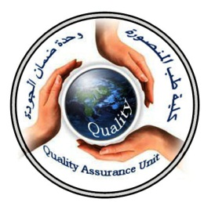

COURSE SPECIFICATION
(Pathology of Tumors)

Faculty of Medicine-MansouraUniversity
- Administrative information

- Programme offering the course: | Postgraduate Master degree of Clinical Oncology and Nuclear Medicine/ CONM517
- Department offering the programme: | Clinical oncology and nuclear medicine department
- Department responsible for teaching the course: | Clinical oncology and nuclear medicine department
- Part of the programme: | second part
- Date of approval by the Department`s council | 14/5/2016
- Date of last approval of programme specification by Faculty council

- Course title: | Pathology of Tumors
- Course code: | CONM 505 path.T
- Credit hours | 3 hours
- Total teaching hours: | 45 hours lectures

- Professional information

- Course Aims:
The broad aims of the course are as follows:(either to be written in items or as a paragraph)
- Educate the different pathologic types of different malignancies.
- Teach the genetic basis of different types of cancers
- Provide the candidate with pathology of cancer of different body partss

- Intended Learning Outcomes (ILOs):
Intended learning outcomes (ILOs); Are four main categories: knowledge & understanding to be gained, intellectual qualities, professional/practical and transferable skills.

On successful completion of the course, the candidate will be able to:
A- Knowledge and Understanding
The trainee should: know and understand:

A1: Explain different pathologic types of different malignancies.
A2: Discus growth and spread of malignant tumors.

A3: Describe importance of pathologic parameters of tumors of different body parts.

2- Intellectual activities (I)
The Postgraduate Degree provides opportunities for candidates to achieve and demonstrate the following intellectual qualities:

B- Intellectual skills

B1: Differentiate between benign and malignant tumor..

B2: Distinguish the biology of tumor growth.
B3: interprete pathology of tumors of different body parts

- Course content:
Subjects | Lectures | Clinical | Laboratory | Field | Total Teaching Hours
*General pathology:  -Neoplasia  -Tumor growth  -Carcinogenesis  -Tumor markers  -Hormones & cancers | 2  2  2  2  2 |  |  |  | 2  2  2  2  2
*Special pathology:  -pathology of head and neck tumers.  - pathology of brain malignancies.  -pathology of lung and pleural cancers  - pathology of gastero-intestinal malignancies  -pathology of female  genital system tumors  - pathology of male genital system tumors | 2  2  2  3  3  2 |  |  |  | 2  2  2  3  3  2
* pathology of urothelial system tumors  * pathology of breast cancer  *pathology Soft tissue  sarcomas  *pathology of Bone sarcomas  *pathology of Skin cancer and melanomas.  *pathology of Cancer of the endocrine system ( thyroid, parathyroid, adrenals, pancreas, carcinoid).  * pathology of Solid tumours of childhood.  *Leukemias, lymphomas and plasma cell neoplasms. | 2  2  2  2  3  3  3  4 |  |  |  | 2  2  2  2  3  3  3  4

- Teaching methods:
4.1: lectures

- Assessment methods:
5.1: written exam for assessment ofKnowledge and intellectual skills.
5.2:oral exam for assessment of Knowledge and intellectual skills.
5.3 MCq continuous assessment for assessment of Knowledge and intellectual skills.

Assessment 1: written exam held after 36 months of admission to job or 30 months of registration to the MS degree.
Assessment 2: Oral exam held after 36 months of admission to job or 30 months of registration to the MS degree.
Assessment 3: MCQ exam held at the end of 2nd, 3rd, 4th semester.

Percentage of each Assessment to the total mark:
Written exam: 120 marks,
MCQ (as a continuous assessment).30marks.
Oral exam: 150 marks, 40% of the 2nd part final exam.

- References of the course:
6.1: Text books:
●PerezCA, Brady LW,Halperin EC,et al.,editors. Principles and Practice of RadiationOncology. 5thed. Philadelphia:Lippincott
Williams& Wilkinns; 2008.
●Hansen EK and Roach M.: Handbook of Evidence-based Radiation
Oncology.1st edition. New York: springer science+ business media,
LLC; 2007.
●Casciato DA, editor.Manual of clinical oncology.6th edition.
Philadelphia: Lippincott Williams&Wilkins; 2009.
●DeVita VT, Hellman S, Rosenberg SA, editors. Principles andPractice of Oncology.8th ed.Philadelphia: Lippincott; 2008.

- Facilities and resources mandatory for course completion:

Candidates and their learning are supported in a number of ways:
□Candidates logbook
□ Programme Specification
□Extensive library and other learning resources
□Computer laboratories with a wide range of software
□Intranet with a wide range of learning support material
□MSc/MD Dissertation Supervisor
Course coordinator:
Prof.d: Soumaya Eiteba
Assisstant prof: Rasha Abdel Latif

Head of the department:
Prof.d: Ibrahim Awad

Date:

P.S. This specification must be done for each course.

