  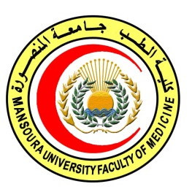 | 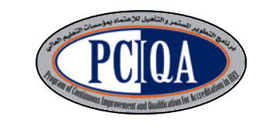 | 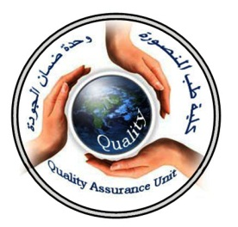

COURSE SPECIFICATION
Elective course
(Genetics related to oncology)
Faculty of Medicine- Mansoura University
- Administrative information

- Programme offering the course: | Postgraduate Master degree of Clinical Oncology and Nuclear Medicine/ CONM517
- Department offering the programme: | Clinical oncology and nuclear medicine department
- Department responsible for teaching the course: | Clinical oncology and nuclear medicine department
- Part of the programme: | second part
- Date of approval by the Department`s council | 14/5/2016
- Date of last approval of programme specification by Faculty council
- Course title: | Genetics related to oncology
- Course code: | CONM517GO
- Total teaching hours: | 30 hours

- Professional information

- Course Aims:
The broad aims of the course are as follows: (either to be written in items or as a paragraph)
- educate the candidate the principles of cancer as genetic disease.
- Prepare them to differentiate different cancer families.
2- Teach them gene therapy.

- Intended Learning Outcomes (ILOs):
Intended learning outcomes (ILOs); Are four main categories: knowledge & understanding to be gained, intellectual qualities, professional/practical and transferable skills.

On successful completion of the course, the candidate will be able to:
A1.define cancer as genetic disease.
A2 : discuss mechanism of cancer predisposition.
A3:recognize types of gene therapy and how to use in treatment.
A4: express gatekeepers, gatetakers, landscapers
A5:explain multisystem genetic syndromes and non syndromic hereditary

A- Knowledge and Understanding

2- Intellectual activities (I)
The Postgraduate Degree provides opportunities for candidates to achieve and demonstrate the following intellectual qualities:

B- Intellectual skills

B1 : differentiate nonsyndromic and syndromic cancer,
B2:apply gene therapy in the treatment of cancer.
B3: recognize character of cancer families.

- Course content:
Subjects | Lectures | Clinical | Laboratory | Field | Total Teaching  Hours
Genetics related to oncology  -cancer as genetic disease  -mechanism of cancer predisposition  -gatekeepers, gatetakers, landscapers  -clinical characteristic of cancer families  -multisystem genetic syndromes  -nonsyndromic hereditary cancer  -gene therapy | 4  4  5  4  4  5  4
- Teaching methods:
4.1: lectures.

- Assessment methods:

5.1: written exam for assessment of Knowledge and understanding.
MCq continuous assessment for assessment of knowledge , intellectual ILOs

Assessment schedule:

Assessment 1: written exam held after 36 months of admission to job or 30 months of registration to the MS degree.
Assessment 2: Oral exam held after 36 months of admission to job or 30 months of registration to the MS degree.
Assessment 3: MCQ exam held at the end of 2nd, 3rd, 4th semester.

Percentage of each Assessment to the total mark:
Written exam:80 marks .
Oral exam: 50 marks.
MCQ (as continuous assessment): 20 marks.

References of the course:

6.2: Text books:

● PerezCA, Brady LW,HalperinEC,etal.,editors.Principles and Practice of RadiationOncology. 5th ed. Philadelphia:Lippincott
Williams&Wilkinns; 2008.
●Hansen EK and Roach M.: Handbook of Evidence-based Radiation
Oncology.1st edition. New York: springer science+ business media,
LLC; 2007.
●Casciato DA, editor. Manual of clinical oncology.6th edition.
Philadelphia: Lippincott Williams&Wilkins; 2009.
●DeVita VT, Hellman S, Rosenberg SA, editors. Principles and Practice of Oncology.8th ed. Philadelphia: Lippincott; 2008.

- Facilities and resources mandatory for course completion:

Candidates and their learning are supported in a number of ways:
□Candidates logbook
□ Programme Specification
□Extensive library and other learning resources
□Computer laboratories with a wide range of software
□Intranet with a wide range of learning support material
□MSc/MD Dissertation Supervisor

Course coordinator:
Prof.d: Soumaya Eteiba
Assistant prof: Rasha Abdel Latif

Head of the department:
Prof.d: Ibrahim Awad

Date:

P.S. This specification must be done for each course.

