  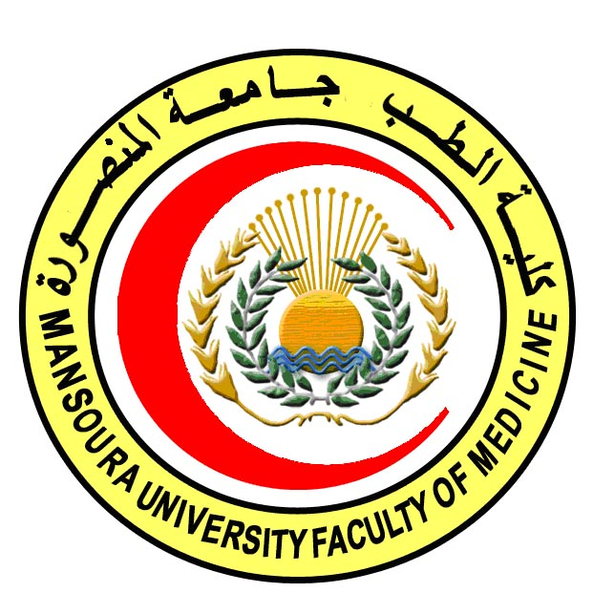 | 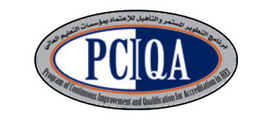 | 

COURSE SPECIFICATION
Histology & Cell biology
Faculty of Medicine- Mansoura University
- Administrative information

- Programme offering the course: | Master degree of Histology & Cytology
- Department offering the programme: | Histology & Cell biology
- Department responsible for teaching the course: | Histology & Cell biology
- Part of the programme: | Second part
- Date of approval by the Department`s council | 28/2/2018
- Date of last approval of programme specification by Faculty council
- Course title: | Histology & Cell biology
- Course code: | HIST 502
- Credit hours | 13 hours lectures  8 hours practical
- Total teaching hours: | 195 lectures  240 practical
- Professional information

- Course Aims:
The broad aims of the course are as follows:
The aim of this course is to prepare the candidate to be professional in the field of Histology and cell biology through increasing his/ her awareness about:
- The cell structure, function, maintenance mechanisms and its specific specialization.
- The microanatomy and ultra-structure of different organs and tissues and the regional variation and its significance.
- The cell and tissue biology.
- Age related changes that occur in cells and tissues.

- Intended Learning Outcomes (ILOs):

Intended learning outcomes (ILOs); Are four main categories: knowledge & understanding to be gained, intellectual qualities, professional/practical and transferable skills.

On successful completion of the course, the candidate will be able to:

A- Knowledge and Understanding
A1 Describe the detailed structure of the cell regarding membranous and non-membranous cell organelles in addition to the structure of the nucleus.
A 2 Describe the different stages of the cell cycle and cell division and to identify karyotyping and chromosomal anomalies.
A3 Describe the microscopic structure of different types of epithelium
A4 Identify general characteristics and structure of connective tissue (synthesis, character, LM & EM), fibers and cells (LM, EM & function)
A5 Describe the detailed microscopic structure of cartilage and bone
A6 Describe the detailed microscopic structure of muscular tissue
A7 Describe the microscopic structure of various elements constituting the nervous tissue
A8 Describe the detailed microscopic structure of various elements constituting the blood and the process of haematopoiesis with describing the detailed structure of bone marrow and different types of blood vessels.
A 9 Describe the detailed microscopic structure of the lymphatic tissue including thymus, lymph node, spleen & tonsil and to review the macrophage system.
A10 Describe the detailed microscopic structure of the respiratory system.
A11 Describe the detailed microscopic structure of the skin and its appendages’.
A12 Describe the microscopic structure of the urinary system (kidney, ureter & urinary bladder)
A13 Describe the structure of gastrointestinal tract
A14 Identify the structure of salivary gland, pancreas and hepato-biliary system
A15 Describe detailed microscopic structure of the male and female reproductive systems.
A16 Identify the structure of the endocrine system.
A17Review the structural details of the cerebrum, cerebellum, CSF and covering meninges
A18 Describe the structure of the different parts of the brain stem (Medulla, Pons, Midbrain and Reticular Formation).
A19 Identify various levels of the spinal cord and related tracts and receptors.
A20 Review the structural details of the eye and ear

B- Intellectual skills

B1 Interpret the differences between the microscopic structure of different body cells and organs.
B2 Relate the light and electron microscopic findings to the function of the cell.
B3 Interpret the different electron-micrographs of different cells of different body organs.
B4- Select appropriate methods to reveal specific microscopic features of cells and tissues.
B5- Diagnose slides different from those seen during his course but of the same organs or tissues previously studied.

C- Professional/practical skills
C1 - Use the microscope efficiently.
C2 Handle the histological glass slides and examine them using the maximum microscopic facilities
C3 Prepare tissues and process them to be examined by light and electron microscopes
C4 Identify different cell organelles
C5 Identify various types of stains & micro techniques
C6 Examine and interpret microscopic slides of normal tissues and organs of the body
C7 Carry out different staining techniques.
C8 Draw and label the structures they have seen under light microscope

D- Communication & Transferable skills
D 1 Search literature as a part of self studying.
D 2 Use the internet to gather information and look for different techniques.
D 3 Present data efficiently and properly
D 4 Acquire continuous self learning skills.
D5 Demonstrate effective presentation skills
D 6 Work in team.

- Course content:
A- Theoretical module:
Subjects | Lectures and seminars | Total Hours
- Cytology  - Introduction, Membranous Cell organelles  - Non- Membranous Cell organelles  - Cell inclusions  - Nucleus  - Cell division  - Karyotyping | 5  5  5  5  5  4.25 | 29.25
- General Histology:  - Epithelium  - Connective tissue  - Cartilage  - Bone  - Muscle tissue  - Nervous tissue  - Blood  - Vascular system  - Lymphatic system  - Respiratory system, The macrophage system | 7  7  4  7  7  8  8  6.25  7  7 | 68.25
- Special Histology:  - Skin  - Urinary System  - Digestive Tract  - Digestive Glands  - Endocrine system  - Male Genital System  - Female Genital System | 7.5  7.5  14.5  6  8.5  7.5  7 | 58.5
- Neurohistology:  - Meninges & CSF  - Spinal cord  - Brain stem  - Cerebrum & Cerebellum  - The Eye & The Ear  - Receptors | 3  8  8  8  8  4 | 39
Total |  | 195
B- Practical module:
Subjects | Practical | Total Hours
- Cytology  - Preparation of tissue sections and identify and handle parts of microscopy  - Performing special stains for mitochondria, Golgi apparatus, centriols, Cell coat.  - Cell inclusions: staining of lipids by Sudan III and Sudan black  - Staining DNA using Feulgin reaction and Methylene green pyronin stain  - Interpretation of electro photographs of mitotic and meiotic cell division  - Interpretation of karyographs showing chromosomal anomalies | 6  6  6  6  6  6 | 36
- General Histology:  - Preparation of paraffin sections of epithelium  - Staining connective tissue by Mallory, Masson, Ver Hoeff, and silver stains.  - Preparation of paraffin sections of different types of cartilage  - Preparation of sections of different types of bone  - Preparation of sections of skeletal, cardiac, and smooth muscle  - Preparation and staining of nerve trunk, spinal and sympathetic ganglia  - Preparation &staining of blood film  - Preparation and staining of different blood vessels  - Preparation and staining of sections of lymph node, thymus, tonsils, spleen  - Preparation and staining of sections of lung and trachea,  - Staining of macrophages | 8  8  8  8  8  8  8  8  8  8  4 | 84
- Special Histology:  - Preparation and staining of sections of thin and thick skin  - Preparation and staining of sections of Tongue dog and rabbit, Esophagus,  - Preparation and staining of sections of Stomach, intestine  - Preparation and staining of sections of digestive glands  - Dissection of endocrine glands, preparation and staining of sections  - Dissection and staining of kidney, ureter, urinary bladder.  - Dissection and staining of testes, prostate, seminal vesicles and penis  - Staining and identification of ovary, uterus, fallopian tube, mammary glands | 9  9  9  9  9  9  9  9 | 72
- Neurohistology:  - Dissection and staining of Meninges, aspiration of CSF  - Dissection and staining Spinal cord  - Dissection and staining medulla, Pons, and midbrain  - Dissection and staining Cerebrum and Cerebellum  - Dissection and staining the Eye and identification of its different parts  - Dissection and staining the Ear  - Staining of Receptors in different tissues; as skin and urinary bladder | 6  7  7  7  7  7  7 | 48
Total |  | 240

- Teaching methods:
4.1: Lectures
4.2: Practical sessions (microscopic analysis of slides consisting of human and animal tissues and organs & electron micrograph reporting)
4.3: Workshops
4.4: Seminars: the student presents a seminar in his/her own field of interest and attends the weekly seminars presented by invited guests, faculty members and students
4.5: Self learning (internet search for specific topics)

- Assessment methods:
5.1: Written exam for assessment of A1-20, B1-5, D1- 5
5.2: OSPE exam for assessment of A1-20, B1-5, C1-8, D1-5
5.3: Structured oral exam for assessment of A1-20, B2-4, D1-6.
5.4: MCQ continuous assessment at the end of each semester for assessment of A1-20,B1-5

(6) Percentage of each assessment to the total mark:
Written exam (50 %) =240 marks
MCQ exam (20% of written exam) =60 marks
OSPE exam (25 %) =150 marks
Structured oral exam (25 %) =150 marks
Other assessment without marks: seminars

(7) References of the course:
6.1: Hand books: Histology and cell biology department book
6.2: Text books: Basic Histology, Bloom & Fawcet Histology, The Cell and Ham’s Histology
6.3: Journals: Histology & histochemistry journal, Cell, Cell biology, Science, Egyptian Journal of Histology and Cytology
6.4: Websites:
http://www.lab.anhb.uwa.edu.au/mb140/
http://www.histology-world.com/stains/stains.htm http://www.bu.edu/histology/m/index.htm
http://www.uni-mainz.de/FB/Medizin/Anatomie/workshop/EM/EMAtlas.html

(8) Facilities and resources mandatory for course completion:
Data show for power point presentations
Laboratories
Library
Computers
Microscopes

Course coordinator: Dr. Shireen Mazroa
Head of the department: Dr. Amal Moustafa
Date: 28/2/2018

