  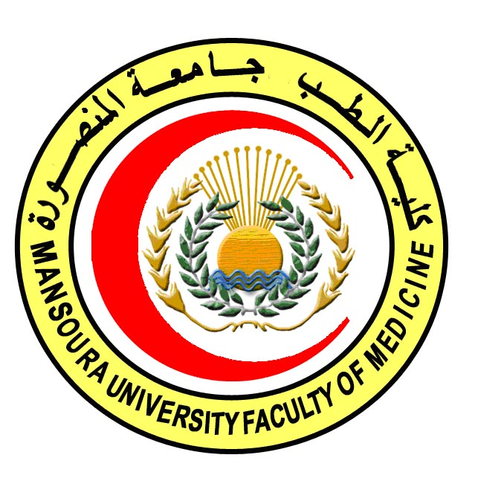 | 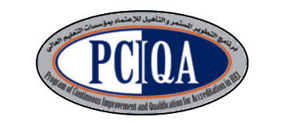 | 

COURSE SPECIFICATION
Pathology
Faculty of Medicine- Mansoura University
- Administrative information

- Programme offering the course: | Master degree of Histology & Cytology
- Department offering the programme: | Histology & Cell biology
- Department responsible for teaching the course: | Pathology
- Part of the programme: | First part
- Date of approval by the Department`s council
- Date of last approval of programme specification by Faculty council
- Course title: | Pathology
- Course code: | HIST 505
- Credit hours | 4 hours (3 lectures-1 practical)
- Total teaching hours: | 60 (45 Lectures-30 practical)

- Professional information

- Course Aims:
The broad aims of the course are as follows:
The aim of this course is to prepare the candidate to be professional in the field of Histology and cell biology through increasing his/ her awareness about
- Age related changes that occur in cells and tissues.
- Structural pathological changes that occur in cells and tissues.

- Intended Learning Outcomes (ILOs):
Intended learning outcomes (ILOs); Are four main categories: knowledge & understanding to be gained, intellectual qualities, professional/practical and transferable skills.

On successful completion of the course, the candidate will be able to:

A- Knowledge and Understanding
A1: Identify the general pathological features of inflammation, tissue repair, cell injury and cell death
A2: Recognize different forms of circulatory disturbances and their underlying pathogenesis
A3: Describe pathological features of various bacterial and parasitic diseases.
A4: Discuss the growth disturbances and differentiate detween benign and malignant tumors.
A5: explain carcinogenesis and discuss different types of neoplasm.

B- Intellectual skills
B1: Analyze various microscopic pathologic data resulting from the disease process.
B2: Interpret findings of pathological specimens effectively.

C- Professional/practical skills
C 1 Examine slides of different tissues and organs

D- Communication & Transferable skills
D 1 Work in team.

D 2 Communicate and use internet

- Course content:

Subjects | Lectures | Laboratory
Reversible cell injury | 3 | 2
Irreversible cell injury:  - Apoptosis | 3 | 2
Irreversible cell injury:  - Necrosis | 3 | 2
Intra cellular and extracellular deposition of:  - Mucin  - Hyalinosis  - Amyloidosis  - Pathological calcification  - Pathological pigmentation | 5 | 4
Acute inflammation | 4 | 2
Chronic inflammation | 4 | 2
Circulatory disturbance:  - Hyperaemia  - Thrombosis  - Embolism | 3 | 2
Circulatory disturbance:  - Ischemia and Infarction  - Gangrene | 2 | 2
Tissue repair:  - cell regeneration  - fibrosis | 3 | 2
Cell adaptation:  - Atrophy  - Hypertrophy | 3 | 2
Cell adaptation:  - Hyperplasia  - Metaplesia  - Displasia | 3 | 2
Neoplasia | 5 | 2
General pathology of infectious diseases | 2 | 2
Diseases of immunity | 2 | 2
 | 45 | 30

- Teaching methods:
4.1: Lectures
4.2: Practical sessions (microscopic analysis of slides consisting of human and animal tissues and organs & electron micrograph reporting)
4.3: Workshops
4.4: Seminars: the student presents a seminar in his/her own field of interest and attends the weekly seminars presented by invited guests, faculty members and students
4.5: Self learning (internet search for specific topics)

- Assessment methods:
5.1: Written exam for assessment of A1-5, B1, D2
5.2: OSPE for assessment of A1-5, B1-2, C1, D2
5.3: Structured oral exam for assessment of A1-5, B1-2, C1, D1-2
5.4 MCQ exam for assessment of A1-5, B1-2, D2:

Percentage of each assessment to the total mark:
- Written exam:
  - Essays 144 marks
  - MCQ: 36 marks
- OSPE: 60 marks
- Structured oral exam: 60 marks

- References of the course:
6.1: Hand books: Pathology department books
6.2: Text books: Rubbin's textbook of pathology and Ackerman's surgical pathology
6.3: Websites: Ovid database, Science direct, Pathmax, Pubmed

- Facilities and resources mandatory for course completion:
Data show for power point presentations
Laboratories
Library
Computers
Microscopes

Course coordinator: Dr. Shireen Mazroa
Assistant coordinator: Dr. Safinaz Mostafa

Head of the department: Dr. Amal Moustafa

Date: 4/2/2018

