  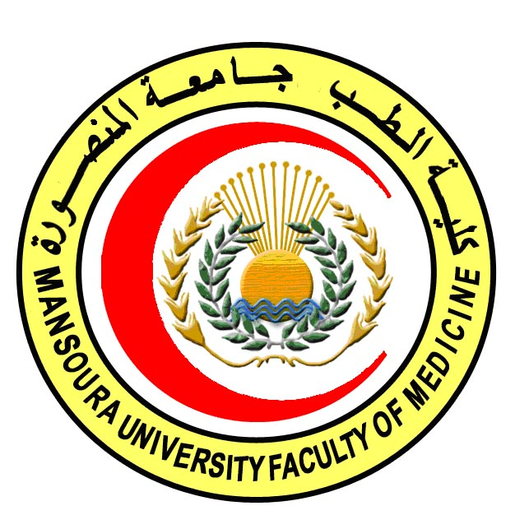 |  | 

COURSE SPECIFICATION
Clinical Chemistry
Faculty of Medicine- Mansoura University
- Administrative information

- Programme offering the course: | MD Degree of Histology & Cytology
- Department offering the programme: | Histology and Cell Biology Department
- Department responsible for teaching the course: | Clinical pathology
- Part of the programme: | Second part
- Date of approval by the Department`s council

- Date of last approval of programme specification by Faculty council
- Course title: | Clinical chemistry
- Course code: | HIST 602 CC
- Credit hours: | 2
- Total teaching hours: | 30
- Professional information

- Course Aims:
The broad aims of the course are as follows:
The aim of this course is to prepare the candidate to be professional in the field of clinical chemistry through increasing his/ her awareness about:
- The laboratory data of normal human and different pathological conditions
- The significance of laboratory data in diagnosis of many diseases.

- Intended Learning Outcomes (ILOs):
Intended learning outcomes (ILOs); Are four main categories: knowledge & understanding to be gained, intellectual qualities, professional/practical and transferable skills.

On successful completion of the course, the candidate will be able to:

A- Knowledge and Understanding
A 1- Recognize the basic physiology of the renal function
Identify the basic categories of renal diseases (glomerunephiritis, acute and chronic renal failure, and uremic syndrome)
A 2- Recognize the laboratory analytic methods for the assessment of renal function
A 3- Discuss the aetiology of liver diseases and the causes of hepatocellular injury
A 4- Describe the dynamics of the liver enzymes and their clinical utility
A 5- Know the liver nonenzymes analysis as albumin,ammonia, bile acids, urea, cholesterol.
A 6- Recognize the clinical manifestation of pancreatic disorders and its diagnostic methodologies
A 7- Discuss physiology, biosynthesis and metabolism of hormones secreted from adrenal gland.
Know the definition, classification, biochemistry and distribution of tumor markers
A 8- Identify the pathophysiology of congestive heart failure and myocardial infarction
A 9- Recognize the utility of different markers of coronary artery diseases.

B- Intellectual skills

B1 Integrate basic laboratory data used to asses' different diseases as cardiac, kidney, liver, gastrointestinal diseases.
B 2 Analyze laboratory data of normal human.

- Course content:
Subjects | Lectures | Clinical | Laboratory | Seminars | Total Teaching Hours
- Renal function tests  - Glomerular  - Tubular | 3  3 | ----- | ----- | ---- | 6
- liver function tests  - aetiologyof liver diseases  - actual liver function  - hepatocellular injury | 2  2  2 | ----- | ---- | ----- | 6
- pancreatic disorders  - adrenal gland  - tumor markers  - Markers of coronary artery diseases. | 4  5  4  5 | ----- | ----- | ----- | 18

- Teaching methods:
4.1: Lectures
4.2: Self learning (internet search for specific topics)

- Assessment methods:
Written exam (80%) = 40 marks
MCQ exam (20%) = 10 marks
Total: 50 marks

- References of the course:
6.1: Hand books: Guide to clinical pathology book.
6.2: Text books: Tietz textbook of clinical chemistry and molecular diagnosis.
6.3: Journals: Clinical Chemistry Journal.

- Facilities and resources mandatory for course completion:
Data show for power point presentations
Library
Computers

Course coordinator: Dr. Shireen Mazroa
Assistant coordinator: Dr.Walaa Hamed

Head of the department: Dr. Amal Mohamed Moustafa
Date: 4/ 2 / 2018

