  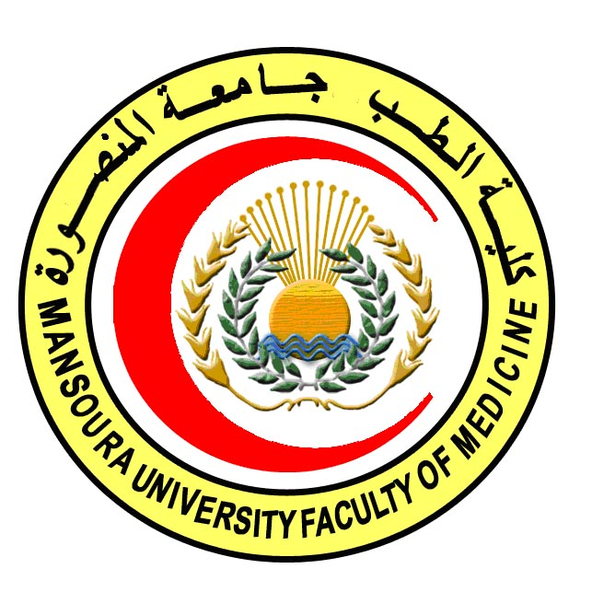 | 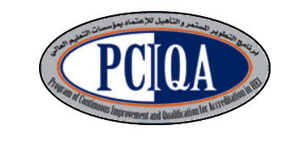 | 

COURSE SPECIFICATION
Advanced Histology & Cell biology
Faculty of Medicine- Mansoura University
- Administrative information

- Programme offering the course: | M.D. degree of Histology & Cytology
- Department offering the programme: | Histology & Cell biology
- Department responsible for teaching the course: | Histology & Cell biology
- Part of the programme: | Second part
- Date of approval by the Department`s council | 28/2/2018
- Date of last approval of programme specification by Faculty council
- Course title: | Advanced Histology & Cell biology
- Course code: | HIST 602
- Credit hours: | 23 theoretical + 12 practical+3 activities
- Total teaching hours: | 345 h theoretical+ 360 h practical

- Professional information

- Course Aims:
The broad aims of the course are as follows:
The aim of this course is to prepare the candidate to be professional in the field of Histology and cell biology through increasing his/ her awareness about the methods of tissue culture and how to use it in different researches.
And to be excellent in the fields of
- Effective communication and leading team in different situations.
- Decision making in vision of the information available.
- Continuous self development and transfer of knowledge and expertise to others
- Advanced diagnostic procedures including hematological, cytological, Immunological and ultra structural investigations.
- Presentation of scientific data pertaining to the field, in conferences both as poster and verbal presentations and to take part in group discussions.

- Intended Learning Outcomes (ILOs):
Intended learning outcomes (ILOs); Are four main categories: knowledge & understanding to be gained, intellectual qualities, professional/practical and transferable skills.
On successful completion of the course, the candidate will be able to:
A- Knowledge and Understanding
A1 Describe the structure of cytoplasmic contents (including membranous and non-membranous cell organelles) and nucleus and to identify how each of them performs its function for the cell.
A 2 Recognize the behavior of different cells during cell cycle and also during cell injury including apoptosis and necrosis.
A3 Describe the microscopic structure of different types of epithelium
A4 Identify general characteristics and structure of connective tissue (synthesis, character, LM & EM), fibers and cells (LM, EM & function)
A5 Describe the detailed microscopic structure of cartilage and bone
A6 Describe the detailed microscopic structure of muscular tissue
A7 Describe the microscopic structure of various elements constituting the nervous tissue
A8 Describe the detailed microscopic structure of various elements constituting the blood and the process of haematopoiesis with describing the detailed structure of bone marrow and different types of blood vessels.
A 9 Describe the detailed microscopic structure of the lymphatic tissue including thymus, lymph node, spleen & tonsil and to review the macrophage system.
A10 Describe the detailed microscopic structure of the respiratory system.
A11 Describe the detailed microscopic structure of the skin and its appendages.
A12 Describe the microscopic structure of the urinary system (kidney, ureter & urinary bladder)
A13 Describe the structure of gastrointestinal tract
A14 Identify the structure of salivary gland, pancreas and hepato-biliary system
A15 Describe detailed microscopic structure of the male and female reproductive systems.
A16 Identify the structure of the endocrine system.
A17Review the structural details of; cerebrum, cerebellum, CSF, covering meninges, thalamus, hypothalamus and limbic system.
A18 Describe the structure of the different parts of the brain stem (Medulla, Pons, Midbrain and Reticular Formation).
A19 Identify various levels of the spinal cord and related tracts and receptors.
A20 Review the structural details and aging effects on; eye, ear, olfaction & taste

B- Intellectual skills
B1 Interpret the differences between the microscopic structure of different body cells and organs.
B2 Relate the light and electron microscopic findings to the function of the cell.
B3 Interpret the different electron-micrographs of different cells of different body organs.
B4- Select appropriate methods to reveal specific microscopic features of cells and tissues.
B5- Diagnose slides different from those seen during his course but of the same organs or tissues previously studied.

C- Professional/practical skills
C1 - Use the microscope efficiently.
C2 Handle the histological glass slides and examine them using the maximum microscopic facilities
C3 Prepare tissues and process them to be examined by light and electron microscopes
C4 Identify different cell organelles
C5 Identify various types of stains & micro techniques
C6 Examine and interpret microscopic slides of normal tissues and organs of the body
C7 Carry out different staining techniques.
C8 Draw and label the structures they have seen under light microscope

D- Communication & Transferable skills
D 1 Search literature as a part of self studying.
D 2 Use the internet to gather information and look for different techniques.
D 3 Present data efficiently and properly
D 4 Acquire continuous self learning skills.
D5 Demonstrate effective presentation skills
D 6 Work in team.
D 7 Use of information technology to serve the development of professional practice
D 8 Teach others and evaluate their performance

Course content:
A- Theoretical module:
Subjects | Lecture | Total
Advanced Cytology  - Introduction, Membranous Cell organelles  - Non- Membranous Cell organelles  - Cell inclusions  - Cell cycle  - Apoptosis and necrosis | 11  10.75  10  10  10 | 51.75
Advanced study of General Histology  - Epithelium  - Connective tissue  - Cartilage  - Bone  - Muscle tissue  - Nervous tissue  - Blood  - Vascular system  - Lymphatic system  - Respiratory system  - The macrophage system | 10  10  7  10  10  11  11  9  10  10  2.75 | 120.75
Advanced study of Special Histology  - Skin  - Urinary System  - Digestive Tract  - Digestive Glands  - Endocrine Glands  - Male Genital System  - Female Genital System | 13  13  25.5  11  15  13  13 | 103.5
Advanced study of Neuro-Histology  - Meninges, CSF  - Spinal cord  - Brain stem  - Cerebrum  - Cerebellum  - Extrapyramidal system  - Thalamus, hypothalamus  - Limbic System  - Olfaction & taste  - Aging of CNS, Alzheimer's D  - The Eye  - The Ear  - Receptors | 5  6  6  5  5  5  6  5  5  5  6  5  5 | 69
Total Teaching Hours |  | 345

B- Practical module (6 h/week):
Subjects | Practical | Total Hours
- Cytology  - Preparation of tissue sections and handle parts of microscopy  - Performing special stains for mitochondria, Golgi apparatus, centriols, Cell coat.  - Cell inclusions: staining of lipids by Sudan III and Sudan black  - Staining DNA using Feulgin reaction and Methylene green pyronin stain  - Interpretation of apoptotic and necrotic cells. | 11  11  10  11  11 | 54
- General Histology:  - Preparation of paraffin sections of epithelium  - Staining connective tissue  - Preparation of paraffin sections of different types of cartilage  - Preparation of sections of different types of bone  - Preparation of sections of skeletal, cardiac, and smooth muscle  - Preparation and staining of nerve trunk, spinal and sympathetic ganglia  - Preparation &staining of blood film  - Preparation and staining of sections of different types of blood vessels.  - Preparation and staining of lymph node, thymus, tonsils, and spleen  - Preparation and staining of sections of lung and trachea  - Staining of macrophages in different organs | 12  12  12  12  12  12  12  12  12  12  6 | 126
- Special Histology:  - Preparation and staining of sections of thin and thick skin  - Preparation and staining of Tongue, Esophagus, Stomach, intestine  - Preparation and staining of sections of digestive glands  - Dissection of endocrine glands, preparation and staining of sections  - Urinary bladder Preparation, Staining of kidney and ureter  - Dissection and staining of testes, prostate, seminal vesicles and penis  - Staining & identification of ovary, uterus,fallopian tube & mammary glands | 13,5  27  13,5  13,5  13,5  13,5  13,5 | 108
- Neurohistology:  - Dissection and staining of Meninges & aspiration of CSF  - Dissection and staining Spinal cord  - Dissection and staining medulla, Pons, and midbrain  - Dissection and staining Cerebrum  - Dissection and staining Cerebellum  - Interpretation of sections demonstrating Extrapyramidal system  - Interpretation of sections of Thalamus & hypothalamus, Limbic System  - Interpretation of sections demonstrating Olfaction & taste  - Interpretation of sections demonstrating Aging of CNS and Alzheimer's D  - Dissection and staining the Eye and identification of its parts  - Dissection and staining the Ear  - Staining of Receptors in different tissues; as skin and urinary bladder | 2  3  3  2  2  2  3  2  2  2  2  2 | 27
Total |  | 360

C- Scientific Activities (Advanced activities done by the candidate):
Subjects | Activities |  |  | Credit Hours
- Preparation and staining of tissues samples | Cytology | Obtaining & processing for 2 samples | Staining of 2 samples | 1
- Preparation and staining of tissues samples | General Histology | Obtaining & processing for 5 samples | Staining of 5 samples | 1
- Preparation and staining of tissues samples | Special Histology | Obtaining & processing for 5 samples | Staining of 5 samples | 1
- Preparation and staining of tissues samples | Neuro-histology: | Obtaining & processing for 2 samples | Staining of 1 sample | 1
- Seminars | - Seminar attendance: 6 year |  |  | 1/2
- Seminars | - Seminar performance: 3/year |  |  | 1/2
- Student teaching | Attendance: 6/ week |  |  | 1
- Student teaching | performance: 4/ week |  |  | 1
- Conferences | Attendance 3/ year |  |  | 1/2
- Workshops attendance | Attendance 1/year |  |  | 1/2
Total |  |  |  | 3 cr hours

- Teaching methods:
4.1: Lectures
4.2: Practical sessions (microscopic analysis of slides consisting of human and animal tissues and organs & electron micrograph reporting)
4.3: Workshops
4.4: Seminars: the student presents a seminar in his/her own field of interest and attends the weekly seminars presented by invited guests, faculty members and students
4.5: Self learning (internet search for specific topics)

- Assessment methods:
5.1: Written exam for assessment of A1-20, B1-5, D1- 5
5.2: OSPE exam for assessment of A1-20, B1-5, C1-8, D1-5
5.3: Structured oral exam for assessment of A1-20, B2-4, D1-6
5.4: MCQ exam for assessment of A1-20,B1-5

Percentage of each assessment to the total mark:
Written exam: 160 MArks
MCQ=40 MArks
OSPE: 100 MArks
Structured oral exam: 100 MArks
Other assessment without marks: seminars.

- References of the course:
6.1: Hand books: Histology and cell biology department book
6.2: Text books: Basic Histology, Bloom & Fawcet Histology, The Cell and Ham’s Histology
6.3: Journals: Histology & histochemistry journal, Cell, Cell biology, Science, Egyptian Journal of Histology and Cytology
6.4: Websites:
http://www.lab.anhb.uwa.edu.au/mb140/
http://www.histology-world.com/stains/stains.htm, http://www.bu.edu/histology/m/index.htm
http://www.uni-mainz.de/FB/Medizin/Anatomie/workshop/EM/EMAtlas.html

- Facilities and resources mandatory for course completion:
Data show for power point presentations
Laboratories
Library
Computers
Microscopes

Course coordinator: Dr. Shireen Mazroa

Head of the department: Dr. Amal Mohamed Moustafa
Date: 28/ 2 / 2018

