  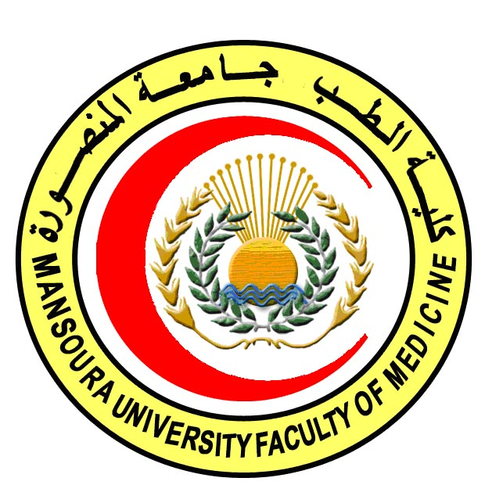 | 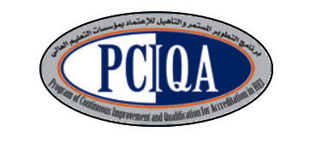 | 

COURSE SPECIFICATION
Hematology
Faculty of Medicine- Mansoura University
- Administrative information
- Programme offering the course: | MD Degree of Histology & Cytology
- Department offering the programme: | Histology and Cell Biology Department
- Department responsible for teaching the course: | Clinical Pathology
- Part of the programme: | Second part
- Date of approval by the Department`s council

- Date of last approval of programme specification by Faculty council
- Course title: | Hematology
- Course code: | HIST 602 HE
- Credit hours: | 2
- Total teaching hours: | 30

- Professional information

- Course Aims:
The broad aims of the course are as follows:
The aim of this course is to prepare the candidate to be professional in the field of hematology. The candidates should acquire satisfactory levels of basic knowledge about hematology. The candidates should keep their medical standards through encouraging the concept of continuing medical education. The program also aims to introduce the candidates to the basics of scientific medical research. This is to be achieved through increasing his/ her awareness about:
- The laboratory data of normal human and different pathological conditions
- The significance of laboratory data in diagnosis of blood diseases.

- Intended Learning Outcomes (ILOs):
Intended learning outcomes (ILOs); Are four main categories: knowledge & understanding to be gained, intellectual qualities, professional/practical and transferable skills.

On successful completion of the course, the candidate will be able to:

A- Knowledge and Understanding
A 1 Recognize structure, function and development of normal blood cells
A 2 Describe disorders of red blood cells
A 3 Discuss the different types of white blood cells, their structure, count, and disorders.
A4 Recognize the normal platelet count and the different platelet disorders.
A5 Discuss Coagulative disorders
A 5 Identify acquired and hereditary blood disorders.
A 6 Recognize mechanisms of advances in hemostasis, fibrinolysis and hemostatic control

B- Intellectual skills

B1 Choose the appropriate laboratory test that help in diagnosis of suspected blood disorder.

B 2 .Integrate patients’ data and basic knowledge to select appropriate laboratory tests that help in diagnosis and management.

- Course content:
Subjects | Lectures | Seminars
1- Erythropoiesis | 2 | ----
2- Hemoglobinopathies | 2
3- General Aspect and types of Anemia | 3
4 -Membranopathies | 2
5- Granulopiosis | 2
6- Leukocytes disorders | 3
7- Histeocytes syndrome | 2
8- Myeloproliferative disorders | 2
9- Myelodysplastic syndrom | 2
10- Lymphopoiessis | 2
11- Lymphoproliferative disorders | 2
12- Platelate disorders | 2
13- Coagulative disorders | 2 | -----
14- Bone marrow failure | 2
Total | 30

- Teaching methods:
4.1: Lectures
4.2: Self learning (internet search for specific topics)

- Assessment methods:
5.1: Written exam for assessment of A1-5, B1, B2.
5.2: MCQ exam for assessment of A1-5, B1, B2

Percentage of each assessment to the total mark:
Written exam: 80% = 40 degrees
MCQ exam: 20% = 10 degrees
References of the course:
6.1: Hand books: Clinical Pathology Department book.
6.2: Text books: Rodak's Hematology: Clinical Principles and Applications,
6.3: Journals: American Journal of Hematology

- Facilities and resources mandatory for course completion:
Data show for power point presentations
Library
Computers

Course coordinator: Prof Dr. Shireen Mazroa

Head of the department: Prof Dr. Amal Moustafa

Date: 24/2/2018

