  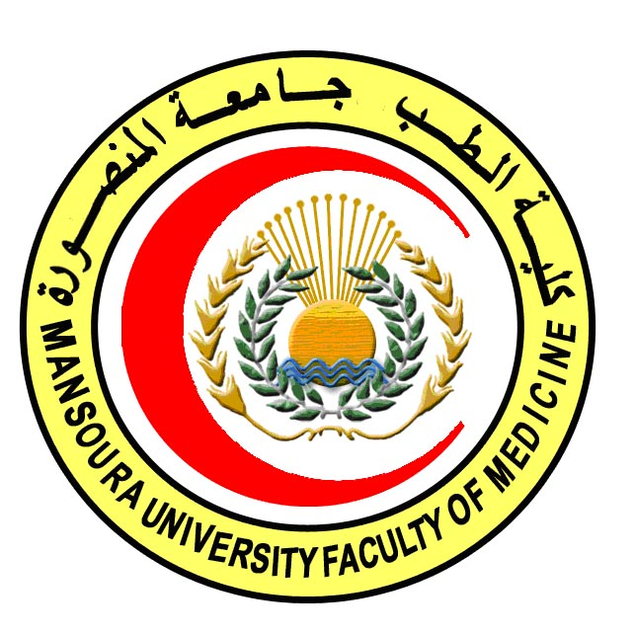 | 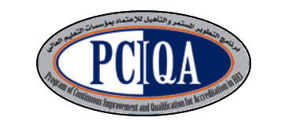 | 

COURSE SPECIFICATION
Immunology
Faculty of Medicine- Mansoura University
- Administrative information

- Programme offering the course: | MD Degree of Histology & Cytology
- Department offering the programme: | Histology and Cell Biology Department
- Department responsible for teaching the course: | Medical Microbiology and Immunology Department
- Part of the programme: | Second part
- Date of approval by the Department`s council

- Date of last approval of programme specification by Faculty council
- Course title: | Immunology
- Course code: | HIST 602 IM
- Credit hours: | 2
- Total teaching hours: | 30
- Professional information

- Course Aims:
The broad aims of the course are as follows:
- To provide the candidate with elements of basic immunology namely lymphocyte biology, antigen presentation, humoral, cellular, mucosal immune responses, inflammation, complement and cytokines.
- To promote the candidate's understanding of diseases related to the immune system emphasizing the hypersensitivity reactions, autoimmunity and immunodeficiency diseases.

- Intended Learning Outcomes (ILOs):
Intended learning outcomes (ILOs); Are four main categories: knowledge & understanding to be gained, intellectual qualities, professional/practical and transferable skills.
On successful completion of the course, the candidate will be able to:

A- Knowledge and Understanding
A 1- Recognize the normal immune system.
A 2- Describe the mechanisms of innate immunity.
A 3- Explain the Complement and kinin systems
A 4- Recognize antigens, Immunoglobulins and understand antigen - antibody reactions, antigen presentation and the major histocompatibility complex.
A 5 Discuss inflammation and the inflammatory response.
A 6- Recognize the humoral and cell mediated immune response
A 7- Explain the mucosal immune system and the hypersensitivity reactions.
A 8- Explain Immune tolerance and principles of autoimmunity.
A 9- Explain the basics of the immunodeficiency diseases, transplantation immunity, and tumour immunity

B- Intellectual skills

B- Intellectual skills

B 1- Interpret the warning signs of immune disorders.
B 2- Achieve a specific or differential diagnosis
B 3- Analyze and explain the type of graft rejection.
B 4- Recognize the mechanism of autoimmune diseases.
knowledge

Course content:
Subjects | Lectures | Seminars
1-Normal immune system | 2 | ----
2- Innate immunity | 2
3- Complement and kinin systems | 2
4- Antigens | 1
5- Immunoglobulins and immunoglobulin genes | 2
6- Antigen - antibody reactions | 2
7- Major histocompatibility complex | 2
8- Inflammation | 2
9- Humoral mmune response 2 | 2
10- Cell mediated immune response | 2
11- Cytokines and chemokines | 2
12- Mucosal immune system | 1
13-Hypersensitivity reactions | 1 | -----
14-Immunodeficiency diseases | 2
15- Immune tolerance and autoimmunity | 2
16- Transplantation immunity | 1
17- Tumour immunity | 2
Total | 30

- Teaching methods:
4.1: Lectures
4.2: Self learning (internet search for specific topics)

- Assessment methods:
5.1: Written exam for assessment of A1-9, B 1-4.
5.2: MCQ Exam for assessment of A1-9, B 1-4

Percentage of each assessment to the total mark:
Written exam: 80%= 40 degrees
MCQ exam: 20% = 10 degrees
References of the course:
6.1: Hand books: Department theoretical books
6.2: Text books:
1. Immunology: Janis Kuby- 2003.
2- Basic Clinical Immunology. Fudenburg, Stites, Caldwell, Weils-1997 6.3: Journals: Immunology
- Facilities and resources mandatory for course completion:
Data show for power point presentations
Library
Computers

Course coordinator: Dr. Shireen Mazroa

Head of the department: Dr. Amal Mohamed Moustafa
Date: 4/ 2 / 2018

