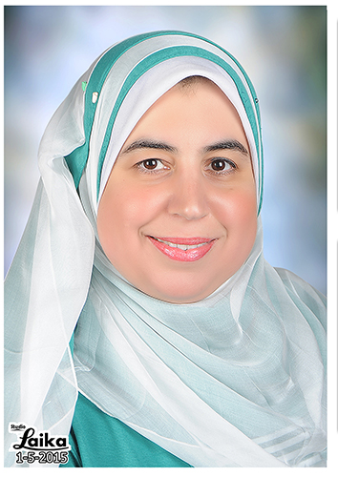 | Jenny Jeehan M. Nasr, PhD.  Associate Professor of Pharmaceutical Analytical Chemistry.  Faculty of Pharmacy, Mansoura University.  Mansoura 35516, Egypt  E-mail: nasrjj@yahoo.com, nasrjj@mans.edu.eg

Research interests:
- Conducting research in the field of analysis of drugs in formulations and biological fluids in addition to stability studies of drug raw materials.
-Conducting research in the field of analysis of drug residues in foods in order to serve the community through avoiding risks to human health.
- Present research focuses on developing green methods of analysis based on nanotechnology to find environment-friendly methods.

Selected Publications:

- Abdallah M. Zeid, Noritada Kaji, Jenny Jeehan M. Nasr, Fathalla F. Belal, Yoshinobu Baba, Mohamed I. Walash "Stacking-cyclodextrin-microchip electrokinetic chromatographic determination of gabapentinoid drugs in pharmaceutical and biological matrices" Journal of Chromatography A, 1503(2017) 65-75

Amirah S. Al-Attas, Jenny Jeehan Nasr, Shereen Shalan, Fathalla Belal "First derivative spectrofluorimetric determination of zopiclone and its degradation product, 2-amino-5-chloropyridine, in pharmaceutical formulations with preliminary tool in biological fluids for clinical evidence of zopiclone intake" Spectrochimica Acta Part A: Molecular and Biomolecular Spectroscopy 181 (2017) 148–152

- Fawzia A. Ibrahim, Amina M. Elbrashy, Jenny Jeehan M. Nasr and Mostafa M. Badr El-Dien “Application of π acceptors to the spectrophotometric and spectrofluorimetric determination of vincamine and naftidrofuryl oxalate in their pharmaceutical preparations” Luminescence 32 (2017) 555–563.

- Abdallah M. Zeid, Jenny Jeehan M. Nasr, Fathalla F. Belal, Shinya Kitagawa, Noritada Kaji, Yoshinobu Baba and Mohamed I. Walash “Determination of six anti-Parkinson drugs using cyclodextrin-capillary electrophoresis method: application to pharmaceutical dosage forms” RSC Advances 6 (2016) 17519- 17530.

Recognitions:

- Mansoura University Prize for Encouragement of Science 2017, Egypt.
- One year fellowship of L'Oreal-UNESCO for Women in Science Pan Arab Regional Programme in association with Arab Science and Technology Foundation (ASTF) 2010.

