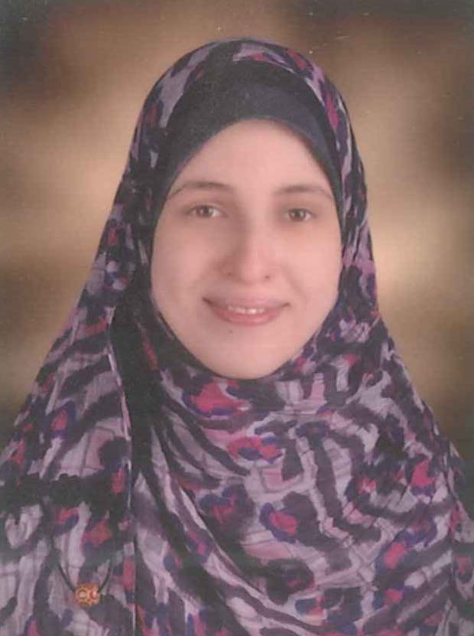 | Name:- Al Shaima Gamal Abd El Salam Abd El Salam  Position:- Assistant Lecturer  Education:- Master degree  E-mail:- alshaimagamal@mans.edu.eg

Research interests:
Breast cancer, metastasis, tumor biomarkers

Selected Publications:
Thioredoxin-1 and MMP-9 as biomarkers in breast cancer metastasis in Egyptian female patients, Al Shaima G. Abd El Salam, Mohamed A. Ebrahim, Laila A. Eissa, Mamdouh M. El-Shishtawy a, Egyptian Journal of Basic and Applied Sciences (EJBAS), https://doi.org/10.1016/j.ejbas.2018.01.001 (2018).

Patents: -

Recognitions: -

Link to detailed C.V:

Link to Personal site: -

Other links:

