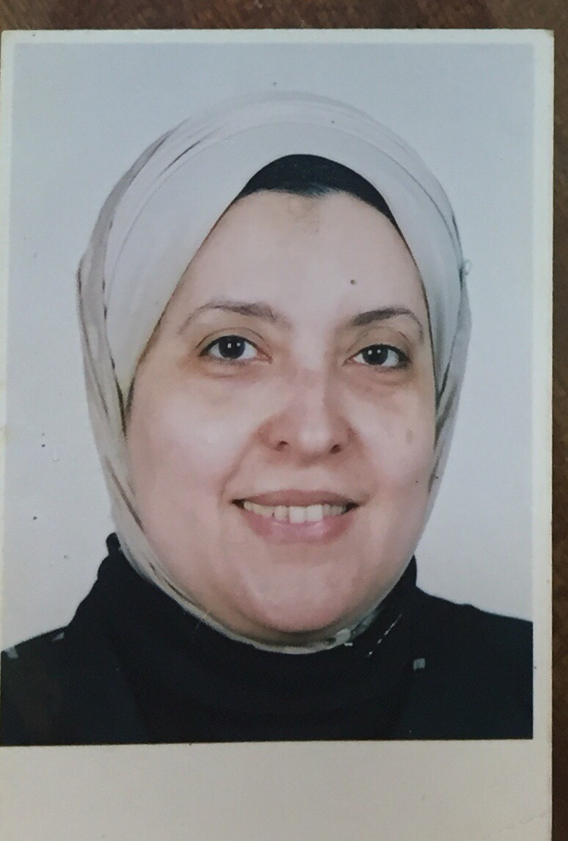 | Name:- Amal Mohammad El Gayar  Position:- Professor of Biochemistry  E-mail:- amalgayar@mans.edu.eg

Research interests:
Biochemistry, Molecular biology, Liver diseases, Diabetes, Hepatocellular carcinoma and oxidative stress.

Selected Publications:
Galectin-3 and matrix metalloproteinase-9: Perspective in management of hepatocellular carcinoma. Eisa NH, Ebrahim MA, Ragab M, Eissa LA, El-Gayar AM. J Oncol Pharm Pract, 2014.
Suramin inhibits hepatic tissue damage in hepatocellular carcinoma through deactivation of heparanase enzyme.Tayel A, Abd El Galil KH, Ebrahim MA, Ibrahim AS, El-Gayar AM, Al-Gayyar MM. Eur J Pharmacol. 2014, 728:151-60.
Chloroquine upregulates TRAIL/TRAILR2 expression and potentiates doxorubicin anti-tumor activity in thioacetamide-induced hepatocellular carcinoma model. Sahar A. Helmy, Mohamed El-Mesery, Amro El-Karef, Laila A.Eissa, Amal M. El Gayar Chemico-Biological Interactions (2018) 279:84-94.

Patents: none

Recognitions: none

Link to detailed C.V:

Link to Personal site: none

Other links: none

