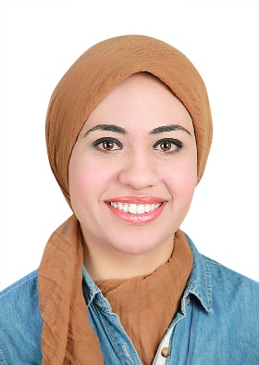
Name:- Yara Adel Rashad Elsayed Samra
Position:- Lecturer of Biochemistry
Education:- Ph.D. in pharmaceutical sciences (Biochemistry)
E-mail:- yaraadel1290@yahoo.com

Research interests:
- The establishment of a viable research program to help in the development of natural sources drugs for cancer, diabetes and other diseases.
- Diabetes and its complications (Nephropathy and Retinopathy).
- Inflammation and its role in different diseases (role of NFκb, inflammasome and cytokines).
- Use microRNAs in the treatment of different diseases.
- Clinical research to find novel markers that can help in early detection and follow up of cancer.

Selected Publications:
- Samra YA, Saleh HM, Hussein KA, Elsherbiny NM, Ibrahim AS, Elmasry K, Fulzele S, El-Shishtawy MM, Eissa LA, Al-Shabrawey M, Liou GI. Adenosine Deaminase-2-Induced Hyperpermeability in Human Retinal Vascular Endothelial Cells Is Suppressed by MicroRNA-146b-3p. Invest Ophthalmol Vis Sci, 58(2): 933-943 (2017).
- Samra YA, Said HS, Elsherbiny NM, Liou GI, El-Shishtawy MM, Eissa LA. Cepharanthine and Piperine ameliorate diabetic nephropathy in rats: role of NF-κB and NLRP3 inflammasome. Life Sci, 157: 187-199 (2016).
- Rashad YA, Elkhodary TR, El-Gayar AM, Eissa LA. Evaluation of Serum Levels of HER2, MMP-9, Nitric Oxide, and Total Antioxidant Capacity in Egyptian Breast Cancer Patients: Correlation with Clinico-Pathological Parameters. Sci Pharm, 82(1): 129-145 (2013).

Patents:

Recognitions:
- Egyptian Government Scholarship (Ministry of Higher Education) to conduct a part of Ph.D. study in Augusta University, Augusta, GA 30912, USA from March 2015-July 2016.
- Certificate of achievement for the successful research in Biomedical Sciences (Inflammation and Diabetic Retinopathy).
- Certificate of training as professional pre-doctoral researcher in Biomedical Sciences.
- Certificate from Dental College of Georgia - Augusta University for the successful visiting research scholar in Biochemistry.

Link to detailed C.V:
http://eupc.mans.edu.eg/V2/get?Dr=29003121200188&T=2&L=A

Link to Personal site:

Other links:
https://scholar.google.com.eg/citations?user=e0KxLuEAAAAJ&hl=en

