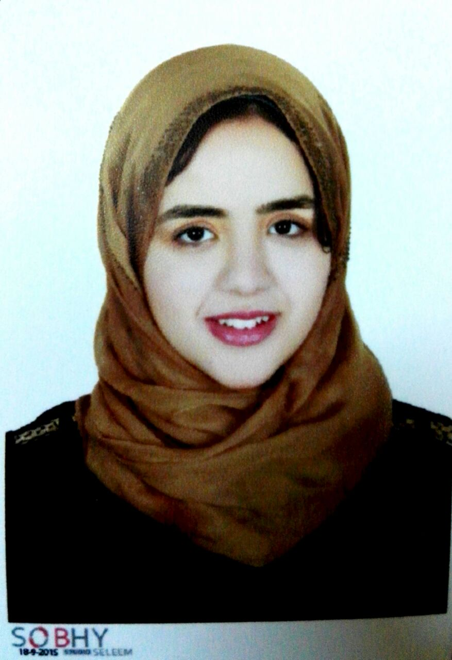
Name:- Mennatallah Alsayed Mohammed Zeyada
Position:- Demonstrator
Education:- Master student in Medical science
E-mail:- mennazeyada@yahoo.com

Research interests:
Liver cancer , Nanotechnology , PCR .

Selected Publications:

Patents: -

Recognitions: -

Link to detailed C.V:

Link to Personal site: -

Other links:

