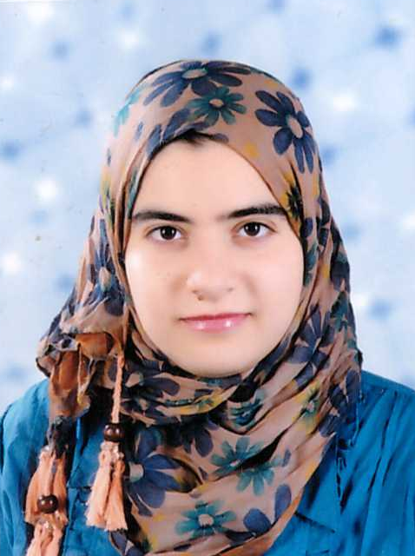 | Name:- Nesma Adel Abd Elrazik  Position:- Demonstrator  Education:- B.Sc.  E-mail:- nesmahabalah@mans.edu.eg

Research interests:
Cancer, Apoptosis and PCR

Selected Publications:

Patents: -

Recognitions: -

Link to detailed C.V:

Link to Personal site: -

Other links:

