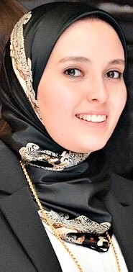 | Name:- Sahar Abd El Gawad Helmy  Position:- Assistant lecturer of Biochemistry  Education:- Master of Science (Pharmaceutical Sciences, Biochemistry), Bachelor degree of science (pharmaceutical sciences): Faculty of Pharmacy, Mansoura University, Mansoura, EGYPT (2014), excellent degree with honor, and graduation ranking 1 st achiever.  E-mail:- sahar_gawad@hotmail.com

Research interests:
Biochemistry, Molecular biology, Liver diseases, Hepatocellular carcinoma and oxidative stress.

Selected Publications:
Chloroquine upregulates TRAIL/TRAILR2 expression and potentiates doxorubicin anti-tumor activity in thioacetamide-induced hepatocellular carcinoma model. Sahar A. Helmy, Mohamed El-Mesery, Amro El-Karef, Laila A.Eissa, Amal M. El Gayar Chemico-Biological Interactions (2018) 279:84-94.

Patents: none

Recognitions: none

Link to detailed C.V:

Link to Personal site: none

Other links: none

