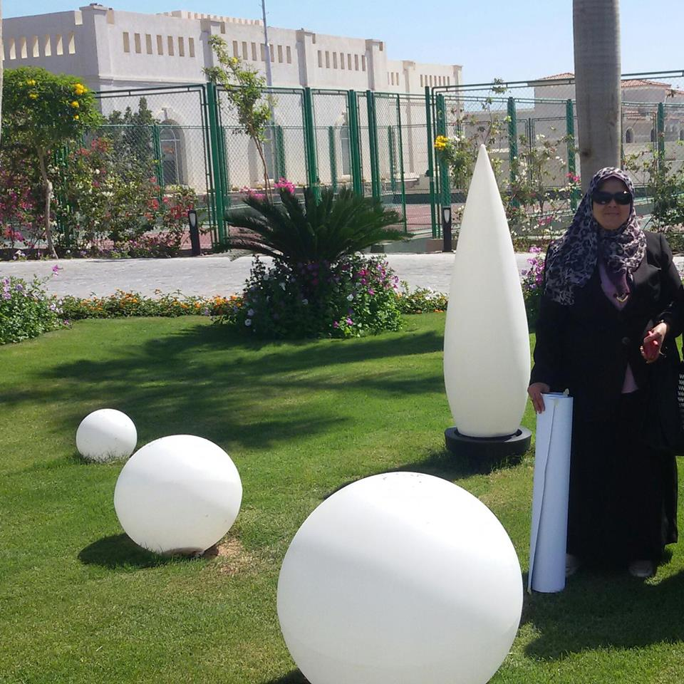
Name:- Laila Ahmed Eissa
Position:-Professor of Biochemistry
E-mail:-Lailaeissa2002@yahoo.com
Education:-
Laila Ahmed Eissa has completed his PhD at the age of 35 years from Mosco Institute of fine chemical technology , Russia .She is the head of department of Biochemsitry , Faculty of Pharmacy Mansoura University , a premier in cancer research and liver disease. She has published more than 43 papers in reputed journals and has been serving as an editorial board member of World Journal of Hepatology.
Research interests: Cancer biology, oxidative stress, liver diseas, apoptosis, metastasis, reactive oxygen species, antioxidants, antioxidant activity, diabetic nephropathy, lipid peroxidation, inflammatory biomarkers, Nano Biomedicine, prognostic biomarkers, diabetic complications, chemoprevention, tumor markers, nephrology, nitric oxide assay, neurology, redox signaling.

Selected Publications:
1.Hepatoprotective effects of glycyrrhizin and omega-3 fatty acids on nuclear factor-kappa B pathway in thioacetamide-induced fibrosis in rats
2.Cepharanthine and piperine ameliorate diabetic nephropathy in rats: Role of NF-κB and NLRP3 inflammasome
3.Galectin-3 and matrix metalloproteinase-9: Perspective in management of hepatocellular carcinoma
4.Effects of omega-3 fatty acids and pioglitazone combination on insulin resistance through fibroblast growth factor 21 in type 2 diabetes mellitus

Selected Publications:

