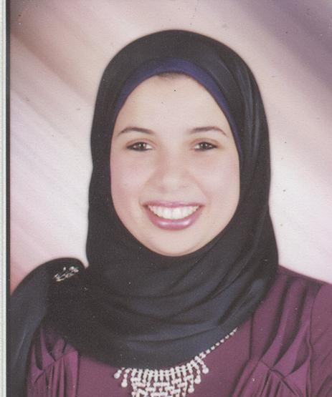 | Name:- Kholoud Alaa ElDin Ibrahim ElMihi  Position:- Assistant Lecturer  Education:- Master of science (Biochemistry)  E-mail:- kholodelmihi@mans.edu.eg

Research interests:
Biochemistry, Molecular biology, Liver diseases, Immunology and oxidative stress.

Selected Publications:
Naringin attenuates thioacetamide-induced liver fibrosis in rats through modulation of the PI3K/Akt pathway. Life Sciences 2017, 187(Supplement C): 50-57.

Patents:

Recognitions:

Link to detailed C.V:

Link to Personal site:

Other links:

