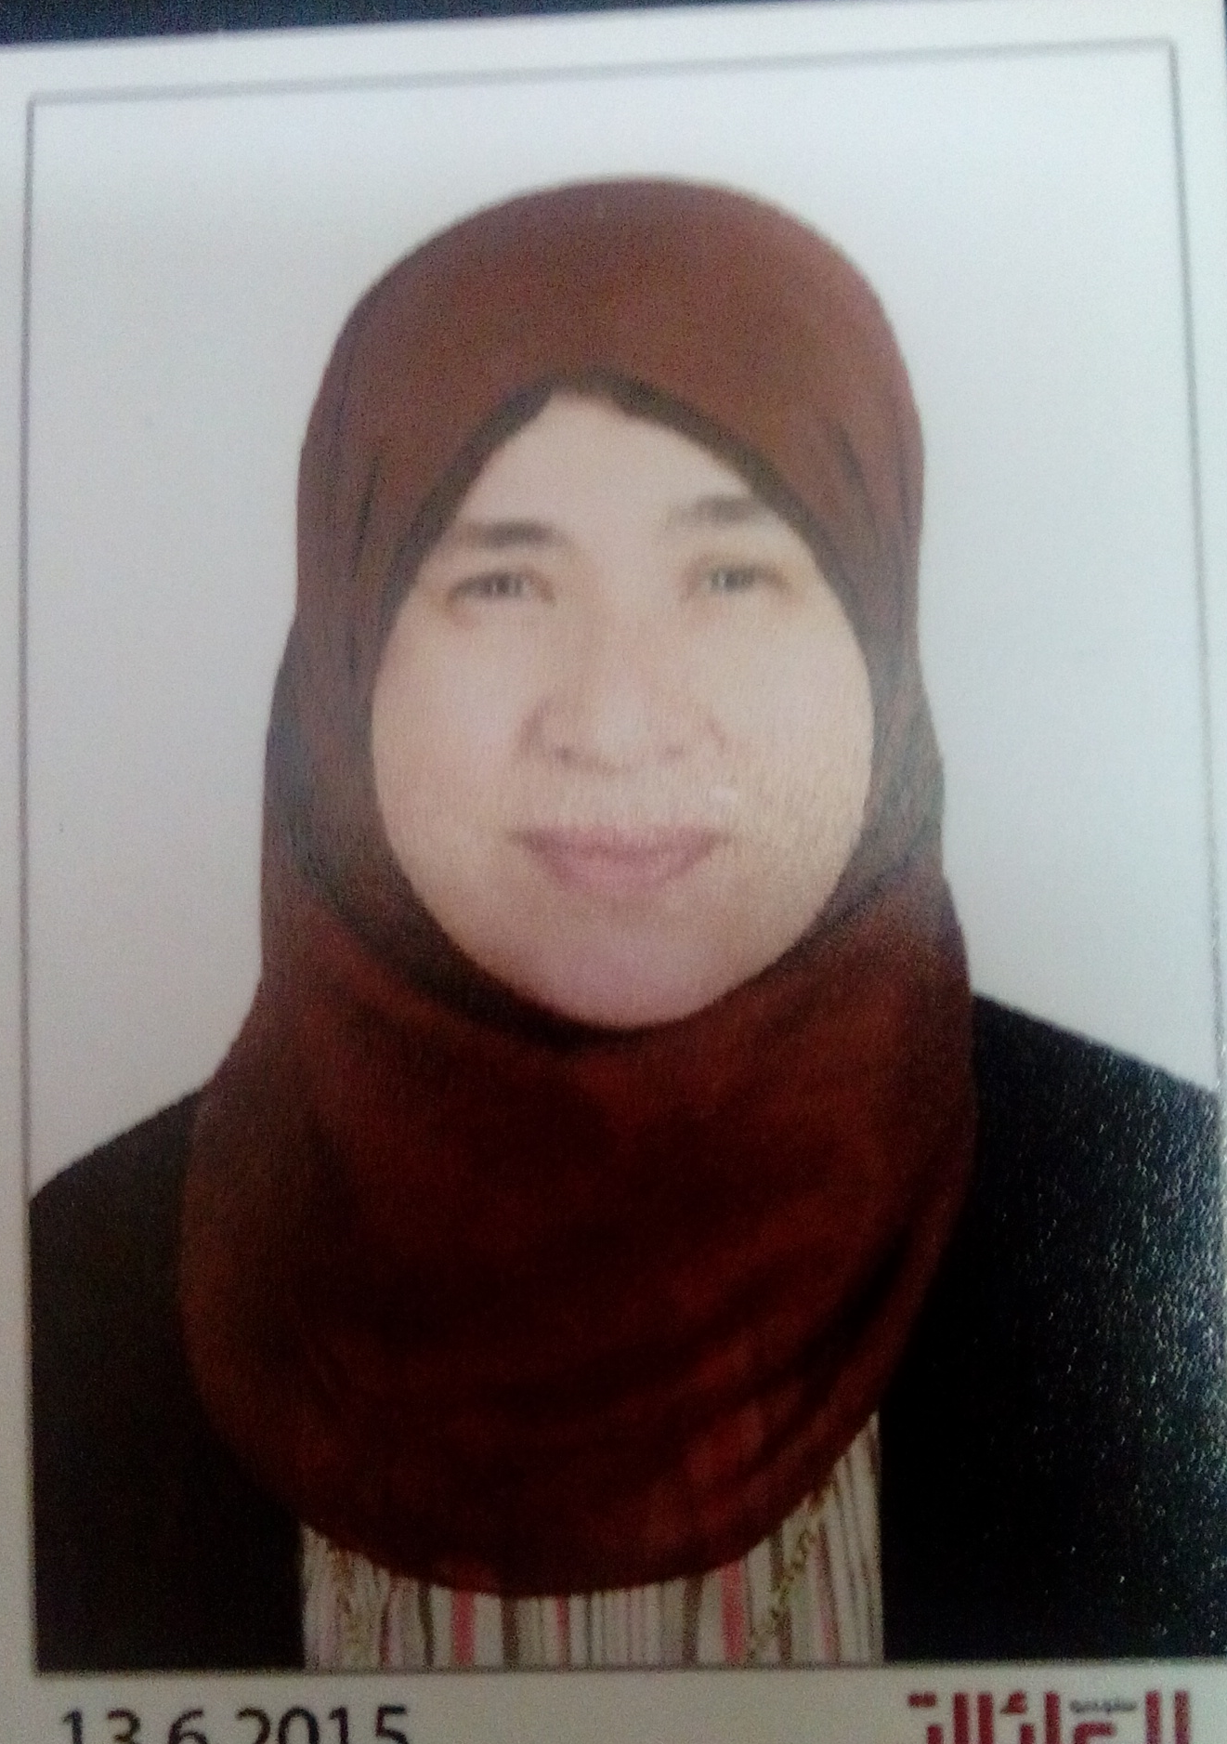
Personal
Photo

Name:- Dalia Rashad El-Wasseef
Position:-Professor of Medicinal Chemistry
Education:-Ph.D
E-mail:-dodomum@yahoo.com

Research interests: Pharmaceutical Analysis

- Selected Publications: Validated spectroscopic methods for determination of anti-histaminic drug azelastine in pure form: Analytical application for quality control of its pharmaceutical preparations. Amal A. El-Masry, Mohammed E.A. Hammoudaa, , , Dalia R. El-Wasseefa, , Saadia M. El-Ashry Spectrochimica Acta Part A: Molecular and Biomolecular Spectroscopy, Volume 191, 15 February 2018, Pages 413–420
- Simultaneous Determination of Formoterol Fumarate and Budesonide Epimers in Metered Dose Inhaler Using Ion-Pair Chromatography
Journal of chromatographic Sciences. Salem YA, Shaldam MA, El-Sherbiny DT, El-Wasseef DR, El-Ashry SM 2017 J Chromatogr Sci. ;55(10):1013-1020
- Validated sensitive spectrofluorimetric method for determination of antihistaminic drug azelastine HCl in pure form and in pharmaceutical dosage forms: application to stability study. Amal A. El-Masry, Mohammed E.A. Hammouda,* Dalia R. El-Wasseef and Saadia M. El-Ashry, Luminescence 2017,32,177-181
- Optimizing the spectrofluorimetric determination of cefdinir through a Taguchi experimental design approach. Noura Hemdan Abou-Taleb, Dalia Rashad El-Wasseef, Dina Tawfik El-Sherbiny and Saadia Mohamed El-Ashry. Luminescence, 2016, 31, 856-864 .

Patents:

Recognitions:

Link to detailed C.V:

Link to Personal site:

Other links:

