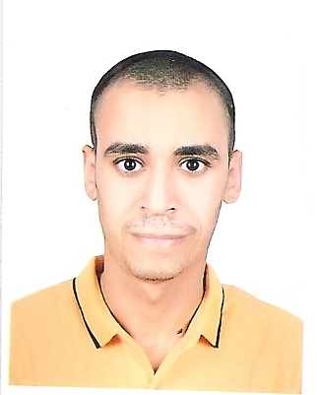  to | Name:- Ahmed Reda Ali Sayed Ahmed Salem  Position:- Assistant Lecturer  Education:- MSc Medicinal Chemistry, BSc Pharmaceutical Sciences  E-mail:- ahmed_reda551988@yahoo.com, ahmed_reda5588@mans.edu.eg

Research interests:
- Medicinal chemistry.
- Computer aided drug design (CADD) & Molecular docking.
- Organic Synthesis.

Selected Publications:

- “Novel acetamidothiazole derivatives: Synthesis and in vitro anticancer evaluation”
European Journal of Medicinal Chemistry 69 (2013) 908-919, PMID: 24125851.
Ahmed R. Ali*, Eman R. El-Bendary, Mariam A. Ghaly, Ihsan A. Shehata

- “Synthesis, in vitro anticancer evaluation and in silico studies of novel imidazo[2,1-b]thiazole derivatives bearing pyrazole moieties”
European Journal of Medicinal Chemistry 75 (2014) 492-500, PMID: 24576591.
Ahmed R. Ali*, Eman R. El-Bendary, Mariam A. Ghaly, Ihsan A. Shehata

- “6-(2-Morpholinoethyl)-thiazolo [3,2-a] pyrimidin-5-one: A novel scaffold for the synthesis of potential
PI3kα inhibitors”
Egyptian Journal of Basic and Applied Sciences, Available online 16 February 2018, https://doi.org/10.1016/j.ejbas.2018.02.001
Ahmed R. Ali, Eman R. El-Bendary, Mariam A. Ghaly*, Ihsan A. Shehata

Patents:

Recognitions:

Link to detailed C.V:
http://pharfac.mans.edu.eg/media/cat_upload/logo_1612750732.pdf
Link to Personal site:
http://www.scopus.com/authid/detail.url?authorId=55915583300
https://www.researchgate.net/profile/Ahmed_Reda4
http://scholar.google.com.eg/citations?user=evvGcyAAAAAJ&hl=en

Other links:

