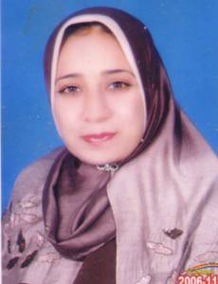

Name:- Nadia Sabry El-gohary
Position:- Associate Professor
Education:- Ph. D. in Medicinal Chemistry
E-mail:- dr.nadiaelgohary@yahoo.com

Research interests: Design and synthesis of new heterocyclic compounds of antimicrobial and antitumor activities

Selected Publications:
- S.A. Abdel-Rahman, N. S. El-Gohary, E. R. El-Bendary, S. M. El-Ashry, M. I. Shaaban, Synthesis, antimicrobial, antiquorum-sensing, antitumor and cytotoxic activities of new series of cyclopenta(hepta)[b]thiophene and fused cyclohepta[b]thiophene analogs. Eur. J. Med. Chem. 2017, 140, 200-211.

- N. S. El-Gohary, M. I. Shaaban, Synthesis and biological evaluation of a new series of benzimidazole derivatives as antimicrobial, antiquorum-sensing and antitumor agents, Eur. J. Med. Chem. 2017, 131, 255-262.

- M. T. Gabr, N. S. El-Gohary, E. R. El-Bendary, M. M. El-Kerdawy. Synthesis and in vitro antitumor activity of new series of benzothiazole and pyrimido[2,1-b]benzothiazole derivatives. Eur. J. Med. Chem. 2014, 85, 576-592.

Patents:

Recognitions:

- University Publication Incentives (2014 and 2015)

Link to detailed C.V:

http://pharfac.mans.edu.eg/media/cat_upload/logo_848097680.pdf

Link to Personal site:

Other links:

