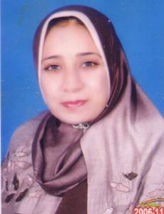 | Name:- Nadia Sabry El-Gohary  Position:- Associate professor of Medicinal Chemistry, Mansoura University  Education:- Ph.D.  E-mail:- dr.nadiaelgohary@yahoo.com

Research interests:
Design and synthesis of new heterocyclic compounds of expected antimicrobial and antitumor activities
Selected Publications:
- S.A. Abdel-Rahman, N. S. El-Gohary, E. R. El-Bendary, S. M. El-Ashry, M. I. Shaaban, Synthesis, antimicrobial, antiquorum-sensing, antitumor and cytotoxic activities of new series of cyclopenta(hepta)[b]thiophene and fused cyclohepta[b]thiophene analogs. Eur. J. Med. Chem. 2017, 140, 200-211.

- N. S. El-Gohary, M. I. Shaaban, Synthesis and biological evaluation of a new series of benzimidazole derivatives as antimicrobial, antiquorum-sensing and antitumor agents, Eur. J. Med. Chem. 2017, 131, 255-262.

- M.T. Gabr, N. S. El-Gohary, E. R. El-Bendary, M. M. El-Kerdawy. Synthesis and in vitro antitumor activity of new series of benzothiazole and pyrimido[2,1-b]benzothiazole derivatives. Eur. J. Med. Chem. 2014, 85, 576-592.

Patents:
Recognitions:

Link to detailed C.V: http://pharfac.mans.edu.eg/media/cat_upload/logo_848097680.pdf
Link to Personal site:
Other links: http://orcid.org/0000-0002-9027-478X . https://scholar.google.com.eg/citations?hl=en&user=d3_dJy4AAAAJ
https://www.scopus.com/authid/detail.uri?authorId=55387498500

