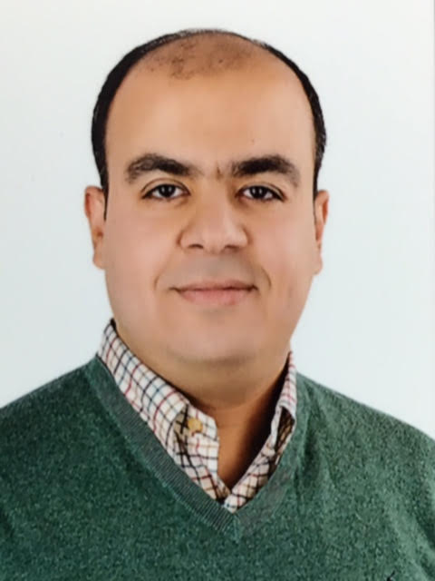

Name:- Walid Mottawea
Position:- Lecturer Microbiology and Immunology.
Education:- Ph.D. Microbiology and Immunology, University of Ottawa, Canada.
E-mail:- wmott020@uottawa.ca

Research interests:
- Gut microbiome in health and disease.
- Microbial genomics.
- Bioinformatics.
- Metagenomics, metabolomics and metatranscriptomics.
- Food Microbiology.
- Environmental Microbiology.
- Molecular Microbiology.

Selected Publications:

- Walid Mottawea, James Butcher, Jennifer Li, Turki Abujamel, David Mack and Alain Stintzi. The Mucosa-Luminal Interface: A Highly Valuable Sample to Study the Mucosa-Associated Microbiota and the Intestinal Microbial Biogeography. Microbiome, Submitted.
• Walid Mottawea, Marc-Olivier Duceppe, Kevin Huang, Julie Jeukens, Luca Freschi, Jean-Guillaume Edmond Rheault, Irena Kukavica-Ibrulj, Brian Boyle, Valentine Usongo, Sadjia Bekal, Roger C. Levesque, Lawrence D. Goodridge and Dele Ogunremi. Salmonella enterica prophage sequence profiles correlate with genome diversity and can be used for high discrimination subtyping. MBio ; Submitted.
• Butcher, Unger, Li, Bando, Romain, Francis, Mottawea, Mack, Stintzi and O’Connor. Microbiota development in very low birth-weight infants exclusively fed mother's own milk. J Nutrition. In Revision.
• Walid Mottawea, Shu Chen, Saleema Saleh-Lakha, Sebastien Belanger, Dele Ogunremi. Complete Genome Sequences of 12 Isolates of Listeria monocytogenes Belonging to Serotypes 1/2a, 1/2b, and 4b, Obtained from Food Products and Food-Processing Environments in Canada. Genome Announc. 2017 May 11;5(19). pii: e00258-17. doi: 10.1128/genomeA.00258-17.
• Jean-Guillaume Emond Rheault , Julie Jeukens, ........, Walid Mottawea , .........., Lawrence Goodridge and Roger C. Levesque. A Syst-OMICS Approach to Ensuring Food Safety and Reducing the Economic Burden of Salmonellosis. Front. Microbiol. | doi: 10.3389/fmicb.2017.00996
• Mottawea W, Chiang C-K, Mühlbauer M, Starr AE, Abujamel T, Deeke SA, Zhou H, Shokralla S, Hajibabaei M, Singleton R, Benchimol EI, Butcher J, Jobin C, Figeys D, Mack D, and Stintzi A. Altered Intestinal Microbiota-Host Mitochondria Crosstalk in New Onset Crohn’s Disease. Nature Communications 2016; doi10.1038/ncomm 13419.
• Amanda E. Starr, Shelley A. Deeke, Zhibin Ning, Cheng-Kang Chiang, Xu Zhang, Walid Mottawea, Ruth Singleton, Eric I. Benchimol, Ming Wen, David R. Mack, Alain Stintzi, and Daniel Figeys. Proteomic analysis of intestinal biopsies from a pediatric inflammatory bowel disease inception cohort identifies proteins that differentiate Crohn’s disease from ulcerative colitis. Gut 2016; doi:10.1136/gutjnl-2015-310705
• Pound LD, Patrick C, Eberhard CE, Mottawea W, Wang GS, Abujamel T, Vandenbeek R, Stintzi A, Scott FW. Cathelicidin antimicrobial peptide: a novel regulator of islet function, islet regeneration and selected gut bacteria. Diabetes. 2015 Dec; 64(12):4135-47.

- Caron AZ, He X, Mottawea W, Seifert EL, Jardine K, Dewar-Darch D, Cron GO, Harper ME, Stintzi A, McBurney MW. The SIRT1 deacetylase protects mice against the symptoms of metabolic syndrome. FASEB J. 2014 Mar; 28(3):1306-16.
• Hoang V, Delatolla R, Abujamel T, Mottawea W, Gadbois A, Laflamme E, Stintzi A. Nitrifying moving bed biofilm reactor (MBBR) biofilm and biomass response to long term exposure to 1 °C. Water Res. 2014 Feb 1; 49:215-24.
• M Askoura, W Mottawea, T Abujamel, I Taher. Efflux pump inhibitors (EPIs) as new antimicrobial agents against Pseudomonas aeruginosa. Libyan Journal of Medicine. 2011, 6 (1).
• Mottawea W, M Askoura, T Abujamel, I Taher. Listeria monocytogenes Internalins: A diverse protein family involved in virulence. Libyan Journal of infectious diseases. 2010, 4(1).

Patents:

- Alain Stintzi, David Mack, Daniel Figeys, Walid Mottawea, Turki Abujamel, Cheng-Kang-Chiang. Methods for the diagnosis and treatment of inflammatory bowel disease. WO 2014138999 A1.

Recognitions:

- Postdoctoral Fellowship in Nutrition-Mental Health Award. School of Nutrition Sciences, University of Ottawa. (2018-2019).
• Postdoctoral Fellowship in Microbial Genomics-Bioinformatics. McGill University. (2016-2017).
• Postdoctoral Fellowship in Microbiome-Host interaction. Ottawa Institute of Systems Biology, University of Ottawa. (2015).
• Ph.D. Scholarship from Egyptian Higher Ministry of Education worth 35,000 Canadian dollars per year (September 2008 – August 2012).
• 2nd place, annual Biochemistry, Microbiology and Immunology Poster Symposium. (May 2013). Department of Biochemistry, Microbiology and Immunology, Faculty of Medicine, University of Ottawa, Ottawa, ON, Canada.
• Best poster view, annual Biochemistry, Microbiology and Immunology Poster Symposium. (May 2013). Department of Biochemistry, Microbiology and Immunology, Faculty of Medicine, University of Ottawa, Ottawa, ON, Canada.
• 1st place, annual Biochemistry, Microbiology and Immunology Seminar Symposium. (February 2012). Department of Biochemistry, Microbiology and Immunology, Faculty of Medicine, University of Ottawa, Ottawa, ON, Canada.
• Nominated by the graduate studies at University of Ottawa to represent Microbiology program at Canadian Student Health Research Forum (CSHRF) presentation competition, Winnipeg, Canada. 2012.

Link to detailed C.V:

Link to Personal site:

Other links:
Google Scholars:
https://scholar.google.ca/citations?user=ZcMq7IEAAAAJ&hl=en
Linkedin:
https://www.linkedin.com/in/walid-mottawea-49825163/
Researchgate: https://www.researchgate.net/profile/Walid_Mottawea?ev=hdr_xprf&_sg=lDtaoOCfnlsb-z83YogXNqU1GoXzQeu2dleWF7vFipwn047LwFLxhCKHKgU9INzO0A3k3oD7gTN4M1lh6HsZR0TH

