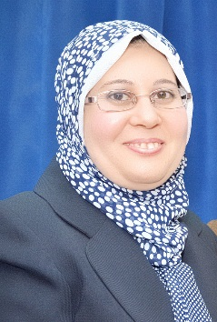ersonal
Photo

Name:- Mona Farouk El-Neketi
Position:- Lecturer in Pharmacognosy Department, Faculty of Pharmacy Mansoura University, Egypt
Education:- Ph.D and master in Pharmaceutical Science, Pharmacognosy, Mansoura University, Egypt
E-mail:- monaneketi@gmail.com

Research interests:
Chemistry of natural products especially those from endophytic fungi
- Bioassay-guided isolation of bioactive compounds from natural sources (Plants, Marine organisms as well as endophytic fungi, as a promising source for bio-pharmaceuticals).
- Induction of bioactive secondary metabolites production by endophytic fungi through co-culture with bacteria.
- Structure elucidation of isolated compounds on the basis of spectroscopic (1D and 2D NMR) and spectrometric (mass) experiments.

Selected Publications:

"Metabolites from the Fungal Endophyte Aspergillus austroafricanus in Axenic Culture and in Fungal−Bacterial Mixed Cultures", Weaam Ebrahim, Mona El-Neketi, Laura-Isabell Lewald, Raha S. Orfali, Wenhan Lin, Nidja Rehberg, Rainer Kalscheuer, Georgios Daletos, and Peter Proksch; Journal of Natural Products, 2016, 79 (4), pp 914–922.

"Alkaloids and Polyketides from Penicillium citrinum, an Endophyte Isolated from the Moroccan Plant Ceratonia siliqua", Mona El-Neketi, Weaam Ebrahim, Wenhan Lin, Sahar Gedara, Farid Badria, Hassan-Elrady A. Saad, Daowan Lai, Peter Proksch; Journal of Natural Products, 2013, 76, 1099−1104.

"Cytotoxic Rocaglamide Derivatives from Aglaia duppereana", Mona El-Neketi, Weaam Ebrahim, Ngoc Tu Duong, Sahar Gedara, Farid Badria, Hassan-Elrady A. Saad, Werner E. G. Müller and Peter Proksch; Z. Naturforsch., 2013, 68 c, 269 – 274.

Patents:
Recognitions:
Link to detailed C.V:
http://eupc.mans.edu.eg/V2/get?Dr=27508041200061&T=2&L=A
my C.V as pdf

Link to Personal site:

Other links:

http://www.scopus.com/authid/detail.url?authorId=55779778700

https://www.researchgate.net/profile/Mona_El-Neketi

https://scholar.google.com/citations?user=rLpUdSYAAAAJ&hl=en

