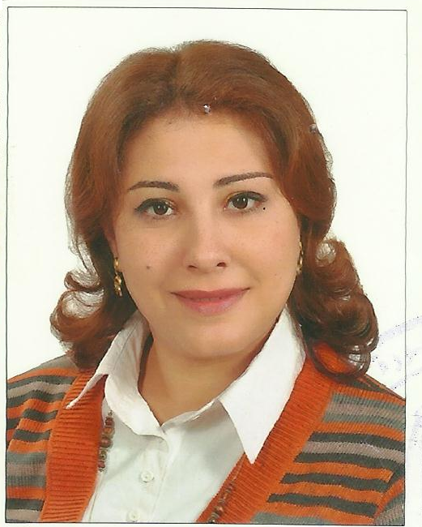
Personal
Photo

Name:-Germeen Nazeer Salama Girgis
Position:-lecturer of pharmaceutics
Education:-Mansoura university
E-mail:-g.girgis2012@yahoo.com

Research interests: ocular drug delivery systems

Selected Publications:
The Potential Use of Atorvastatin Calcium/Hydroxypropyl-β-Cyclodextrin complex loaded Hydrogel as an Ocular Delivery System.

Patents:--------------

Recognitions:

Link to detailed C.V:

Link to Personal site:

Other links:

