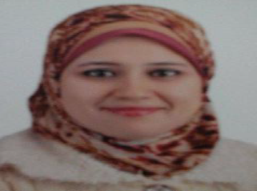

Name:- Noha Mohammed Saleh Marey
Position:- Lecturer at Department of Pharmaceutics, Mansoura University
Education:-
- Bachelor of Pharmaceutical Sciences
- Master in pharmaceutical sciences (Pharmaceutics)
- PhD in pharmaceutical sciences (Pharmaceutics)
E-mail:-
nunu_ramy@yahoo.com, nunu_ramy@mans.edu.eg

Research interests:
- Formulation and characterization of different drugs in bioadhesive gels and tablets.
- Preparation and optimization of polymeric nanoparticles as novel drug-carrier.
- Formulation and evaluation of transdermal patches (reservoir and matrix types).
- Preparation and characterization of microemulsions as drug delivery systems.
- Incorporation of different drug into various dosage forms.

Selected Publications:
- Clindamycin Bioadhesive Gel Formulations for Localized Treatment of Periodontitis
E. Ramadan, Th. Borg, Y.M El Hawary, N.M. Saleh
Mansoura Journal of Pharmaceutical Sciences 25 (2), 167-177, 2009.
- Formulation and evaluation of metronidazole bioadhesive matrices for treatment of periodontitis
E Ramadan, TH Borg, YM El Hawary, NM Saleh
Bull Pharm Sci 33, 79-94, 2010.
- Formulation and evaluation of acyclovir microemulsions
E Ramadan, T Borg, GM Abdelghani, NM Saleh
Bulletin of Pharmaceutical Sciences 36, 31-47, 2013.
- Transdermal microneedle-mediated delivery of polymeric lamivudine-loaded nanoparticles
E Ramadan, T Borg, GM Abdelghani, NM Saleh
Journal of Pharmaceutical Technology and Drug Research 5 (1), 1, 2016.

Patents: Not found.

Recognitions: Not found.

Link to detailed C.V:

Link to Personal site: Not found.

Other links:

