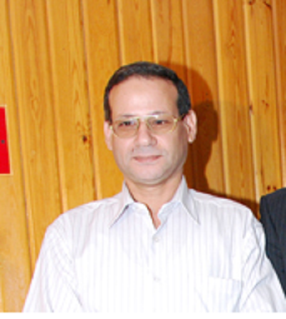
Personal
Photo

Name:- Osama Abd El-Azeem Soliman
Position:- Professor of Pharmaceutics
Education:- Ph. Degree of Pharmaceutics
E-mail:-osamasoliman2000@yahoo.com

Research interests: Formulation and Evaluation of Ophthalmic Dosage Forms, Complexation and Confirmation of Drugs, Improvement of drugs Bioavailability

Selected Publications: Improvement of the Ocular Bioavailability of Econazole Nitrate upon Complexation with Cyclodextrins,
Abd El-Gawad H. Abd El-Gawad, Osama A. Soliman, Marwa S. El-Dahhan, Saeed A. S. Al-Zuhairy, AAPS PharmSciTech.

Water-soluble Complex Of Curcumin With Cyclodextrins: Enhanced Physical Properties For Ocular Drug Delivery, Maria DN, Mishra SR, Wang L, Abd-Elgawad AH, Soliman OA, El-Dahan MS, Jablonski MM¹, Curr Drug Deliv. 2016, Vol. 13, Aug 8.

Nimodipine Ophthalmic Formulations for Management of Glaucoma, Maria DN, Mishra SR, Wang L, Abd-Elgawad AH, Soliman OA, El-Dahan MS, Jablonski MM¹, Pharmaceutical Research.

Stability and Ocular Pharmacokinetics of Celecoxib-Loaded Nanoparticle Topical Ophthalmic Formulations, Mohamed Mostafa Ibrahim, Abd El-Gawad Helmy Abd El-Gawad, Osama Abd El-Azeem Soliman, Monica M. Jablonski, Journal of Pharmaceutical Sciences, 22 September, (2016)

Potential Use of Cyclodextrins for the Improvement of Ocular Bioavailability of Meloxicam, Abd-Elgawad H. Abd-Elgawad, Osama A. Soliman, Marwa S. El-Dahan, Ghada A. El-Emam, IOSR Journal of Pharmacy and Biological Sciences, Volume 12, Issue 5 Ver. I (Sep. – Oct. 2017), PP 79-96.

atents:

Recognitions: N/A

Link to detailed C.V: Google schoolar

Link to Personal site: N/A

Other links:N/A

