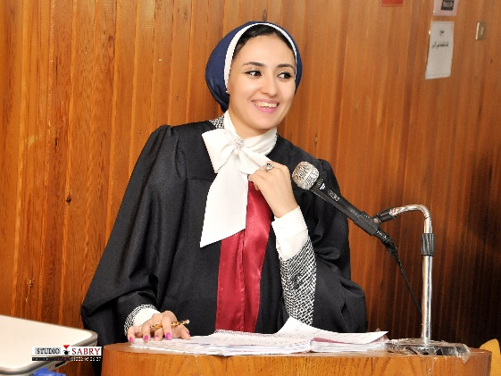

Name:- Mirhan N. Makled
Position:- Lecturer
Education:- PhD
E-mail:- mirhan_makled@hotmail.com
mirhan_makled@mans.edu.eg

Research interests:
- Experimental research: Diabetic nephropathy, colorectal cancer, vascular pharmacology, asthma, renal pharmacology, hepatic pharmacology, Molecular pharmacology, Surgery (Cecal ligation and puncture model and renal Ischemia/reperfusion injury model, unilateral ureteral obstruction).
- Clinical research: Lower urinary tract symptoms associated with benign prostatic hyperplasic

Selected Publications:

Mirhan N. Makled, Mohammed S. El-Awady, Rania R. Abdelaziz, Nadia Atwan, Emma T. Guns, Nariman M. Gameil, Ahmed B. Shehab El-Din, Elsayed M. Ammar (2016): Pomegranate protects liver against cecal ligation and puncture-induced oxidative stress and inflammation in rats throughTLR4/NF-κB pathway inhibition. Environmental Toxicology and Pharmacology.

El-Agamy, D.S., Makled, M.N. and Gamil, N.M (2013): Protective effects of agmatine against dgalactosamine and lipopolysaccharide induced fulminant hepatic failure in mice. Inflammopharmacology.

El-Agamy, D.S., Makled, M.N. and Gamil, N.M (2013): Protective effects of BML-111 against acetaminophen-induced acute liver injury in mice. J Physiol Biochem.

Link to detailed C.V:

Other links:
https://scholar.google.com.eg/citationshl=ar&authorid=2099915384969091
https://www.researchgate.net/profile/Mirhan_Makled2

