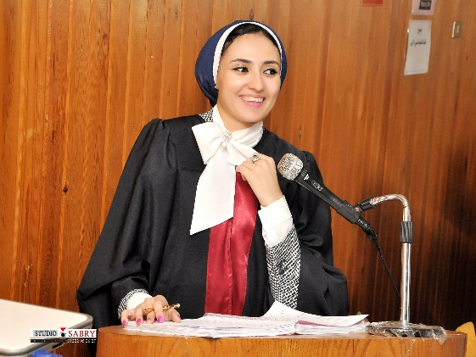

|  |
| --- |
| CURRICULUM VITAE |

**Mirhan N. Makled, PhD**

|  |
| --- |
| Personal |

**Address:** Department of Pharmacology and Toxicology, Faculty of Pharmacy, Mansoura University, Mansoura 35516, EGYPT

Telephone: 002 050 2247496

Fax: 002 050 2247496

E-mail: [mirhan_makled@hotmail.com](mailto:mirhan_makled@hotmail.com)

[mirhan_makled@mans.edu.eg](mailto:mirhan_makled@mans.edu.eg)

**Place of Birth:** Dakahlia, Egypt.

**Marital status:** Single.

|  |
| --- |
| Education |

**Ph.D. in Pharmaceutical Sciences (Pharmacology) (3/2014-9/2016):**

University of Mansoura, Mansoura, Egypt.

**Thesis title:** “Effect of Pomegranate Extracts on Some Models of Experimental Inflammation in Rats and its Therapeutic Value”.

**M.Sc. in Pharmaceutical Sciences (Pharmacology) (7/2011-12/2013):**

University of Mansoura, Mansoura, Egypt.

**Thesis title:** "Study of Efficacy of Some Natural and Synthetic compounds against Experimentally Induced Liver Damage”

**B.Sc. in Pharmaceutical Sciences (2005-2010):**

Faculty of Pharmacy, University of Mansoura, Mansoura, Egypt (Excellent with high honor, graduation ranking 3rd).

|  |
| --- |
| Work Experience |

**01/2014-2016**

Assistant lecturer, Department of Pharmacology and Toxicology, Faculty of Pharmacy, University of Mansoura, Mansoura, Egypt.

**11/2010-1/2014**

Demonstrator, Department of Pharmacology and Toxicology, Faculty of Pharmacy, University of Mansoura, Mansoura, Egypt.

|  |
| --- |
| Teaching Experience |

1. **Undergraduate courses:**
2. Teaching practical Pharmacology courses for preparatory and 3rd year pharmacy students (General Program).
3. Teaching practical Toxicology course for 4th year pharmacy students (General Program).
4. Teaching practical Statistics and Bioassay course for 3rd year pharmacy students (General Program).
5. Teaching practical Pharmacology course for 2nd year dental medicine students (General Program).
6. Teaching practical physiology course for 2nd level pharmacy students (Clinical Pharmacy Program).
7. Teaching practical Pharmacology I course for 3rd level pharmacy students (Credit Hours Program).
8. Teaching practical physiology course for 2nd level pharmacy students (Credit Hours Program).
9. **Postgraduate courses:**
10. Teaching Molecular and Biochemical Toxicology course for Toxicology and Forensic Chemical Analysis Diploma students.
11. Teaching Basic and Clinical Toxicology course for Toxicology and Forensic Chemical Analysis Diploma students.
12. Teaching Advanced Therapeutic I course for PharmD Program students.

|  |
| --- |
| Research skills |

**Experimental Research:**

* Experimental animals handling and injection.
* Withdrawing the blood samples from different experimental animals.
* ELISA Technique.
* qRT-PCR Technique.
* Isolation of pulmonary artery and studying vasoreactivity of pulmonary artery using physiograph.
* Lung, liver and kidney inflammation.
* Surgery (Cecal ligation and puncture model and renal Ischemia/reperfusion injury model).
* Estimation of respiratory rate using physiograph.
* Estimation of Heart rate using a single channel electrocardiograph.
* WBCs counting in urine using hemocytometer.
* Statistical analysis of data and scientific writing.

**Clinical Research:**

* Studying effect of pomegranate fruit extract on lower urinary tract symptoms secondary to benign prostatic hyperplasia.

|  |
| --- |
| Computer skills |

UNESCO certified **International Computer Driving License certificate**

|  |
| --- |
| Language skills |

**Arabic:** mother tongue, very good writing and fluent speaking**.**  
**English:** Very good (International TOEFL certificate).

|  |
| --- |
| Training courses |

A. Faculty and Leadership Development Project **"FLDP"** Training Courses:

1. **Communication skills in the different aspects of education.**
2. **Ethics of scientific research.**
3. **Quality standards in the teaching process**
4. **Financial and legal aspects of the undergraduate Business**
5. **Time and meeting management**
6. **The use of technology in teaching.**
7. **Effective presentation**
8. **Strategic planning.**
9. **Behaviors of the profession.**
10. **Local and global competitive research projects**
11. **Statistical analysis skills**
12. **Credit hours program**

B. Instructor preparation course.

|  |
| --- |
| Publications |

**PhD publication:**

**Mirhan N. Makled, Mohammed S. El-Awady, Rania R. Abdelaziz, Nadia Atwan, Emma T. Guns, Nariman M. Gameil, Ahmed B. Shehab El-Din, Elsayed M. Ammar (2016):** Pomegranate protects liver against cecal ligation and puncture-induced oxidative stress and inflammation in rats throughTLR4/NF-κB pathway inhibition. Environmental Toxicology and Pharmacology.

**Master publications:**

**El-Agamy, D.S., Makled, M.N. and Gamil, N.M (2013):** Protective effects of agmatine against dgalactosamine and lipopolysaccharide induced fulminant hepatic failure in mice. Inflammopharmacology.

**El-Agamy, D.S., Makled, M.N. and Gamil, N.M (2013):** Protective effects of BML‑111 against acetaminophen-induced acute liver injury in mice. J Physiol Biochem.

|  |
| --- |
| Activities |

1. Quality Assurance and Accreditation Unit (Department Coordinator).
2. Summer training of the undergraduate Pharmacy students (Supervisor).
3. The first National Conference University and Industry “role of the University in Economic Development”.
4. Member in the team preparing the annual report of the college.
5. Member in the committee updating and developing the website of the college.
6. 5th Scientific Conference for Pharmacy Students (Evaluator).