Curriculum vitae
Sara Mohamed Hesham Hazem Ibrahim
- Personal Details:

Name: | Sara Mohamed Hesham Hazem Ibrahim | 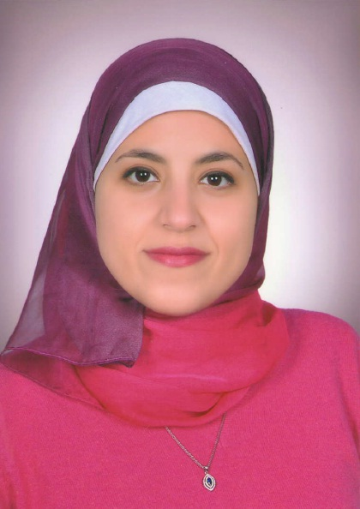
Date of Birth: | 20th September 1990
Nationality: | Egyptian
Address: | Faculty of pharmacy, Mansoura university, Mansoura, Egypt.
Marital Status: | Married
E-mail: | sarahesham12@yahoo.com
Home Tel.: | +20502164030
Mobile Tel.: | +201000741008

II. Educational Qualifications:

1) September 2007 - May 2012:

Bachelor of Pharmacy (clinical pharmacy) (93.26%, GPA 3.95 points out of 4).
Faculty of Pharmacy, Mansoura University, Egypt.

2) January 2013 – October 2015:
Master degree in pharmaceutical sciences (Pharmacology and Toxicology).
Faculty of Pharmacy, Mansoura University, Egypt.
Thesis title: Effect of Janus kinase Inhibition on Experimentally Induced Liver Injury

III. Work Experience:

1) November 2012 till October 2015

Demonstrator of Pharmacology, Pharmacology and Toxicology Department, Faculty of
Pharmacy, Mansoura University, Egypt.

-Responsible for teaching undergraduate students Physiology, Pharmacology, Bioassay and Toxicology practical curriculum.
2) October 2015 till now
Assistant lecturer, Pharmacology and Toxicology Department, Faculty of
Pharmacy, Mansoura University, Egypt.

IV. Research Capabilities:

-All aspects of handling and drug administration for experimental animals.

-Good experience in manipulation of intact experimental animals, preparation of biological samples and isolation of organs from experimental animals for experimental procedures.
-Analysis of biological samples using spectrophotometric and ELISA techniques.
-Good experience in preparation of tissues for histopathological examination.
-Statistical analysis of data.

V. Additional Information:

1) Languages
-Arabic: Mother tongue
-English: TOEFL IBT score 97, GRE general test score 301.

2) Computer Knowledge
-Experienced use of windows and microsoft office products (obtained ICDL).

VI. Publications:
 | Publication | Authors | Journal | Impact Factor
1 | Inhibition of the JAK/STAT pathway by ruxolitinib ameliorates thioacetamide-induced hepatotoxicity | Shaker ME, Hazem SH, Ashamallah SA | Food Chem Toxicol. 2016; 96: 290-301 | 3.584
2 | The novel Janus kinase inhibitor ruxolitinib confers protection against carbon tetrachloride-induced hepatotoxicity via multiple mechanisms | Hazem SH, Shaker ME, Ashamallah SA, Ibrahim TM | Chem Biol Interact. 2014; 220:116-127 | 2.618

